**Insurance Incentive Compensation Management**

**Version 1.0**



|  |  |  |  |
| --- | --- | --- | --- |
|  | **Prepared By / Last Updated By** | **Reviewed By** | **Approved By** |
| **Name** | Arindam Chakraborty  Rahul Sinha  Subhendu Hazra | Indranil Chakraborty |  |
| **Role** |  |  |  |
| **Signature** |  |  |  |
| **Date** | 10/31/2012 | 12/08/2012 |  |

Table of Contents

Chapter 1 - Insurance 5

1.0 Insurance 6

1.1 A Brief History 6

1.2 Definition 6

1.3 Types of Insurance 7

1.3.1 Life Insurance 7

1.3.2 Health Insurance 8

1.3.3 Property and Casualty Insurance 8

1.3.4 Annuities 8

1.4 The Insurance Policy 8

1.5 Group and Individual Insurance 8

1.6 Insurance Organization 10

1.6.1 Ownership Based Classification 10

1.6.2 Place of Incorporation Based Classification 11

1.6.3 Licensing status Based Classification 11

1.6.4 Marketing or Distribution system Based Classification 11

1.7 Insurance Regulation 12

1.7.1 Why regulate 12

1.7.2 What is regulated 12

1.7.3 Who regulates 13

1.8 Insurance Process 14

1.9 Importance of Insurance 15

Chapter 2 - Producer Management 16

2.0 Producer Management 17

2.1 Who is a Producer 17

2.2 Types of Producer 17

2.2.1 Insurance Agents 17

2.2.2 Corporate Agents 18

2.2.3 Insurance Brokers 18

2.2.4 Insurance Agencies 18

2.3 Producer Eligibility 19

2.4 Types of Licenses 19

2.4.1 Insurance Producer 20

2.4.2 Surplus Lines Insurance Producer 20

2.4.3 Limited Lines Producer 20

2.4.4 Limited Lines Credit Producer 20

2.4.5 Consultant 20

2.5 Regulatory Bodies 21

2.5.1 NAIC 21

2.5.2 NIPR 21

2.5.3 State Insurance Departments 21

2.5.4 DTCC 22

2.5.5 NSCC 22

2.5.6 SEC 22

2.6 How to become an Insurance Agent 22

2.6.1 Independent Agent 22

2.6.2 Captive Agent 23

2.7 Producer On-Boarding 23

2.8 Producer Licensing 26

2.8.1 License Issue through an Insurance Carrier 28

2.8.2 License Renewal 29

2.8.3 License Termination 30

2.9 Producer Appointing 31

2.9.1 New Appointment 33

2.9.2 Appointment Renewal 34

2.9.3 Appointment Termination 35

2.10 Producer Contracting 35

2.11 Organization Hierarchy 36

2.12 Producer Management System 37

Chapter 3 - Incentive Compensation Management 42

3.0 Compensation Management 43

3.1 Types of Compensation 43

3.1.1 Compensation Classification – Direct and Indirect 43

3.1.2 Compensation Classification – Base Salary and Incentive 46

3.2 Commission 47

3.2.1 Commission Types 47

3.2.1.1. Base plus commissions 47

3.2.1.2. Straight commissions 47

3.2.1.3. Graduated commissions 47

3.2.1.4. Residual commissions 48

3.2.1.5. Split Commissions 48

3.2.1.6. Overriding commission 48

3.2.1.7. Chargeback 49

3.2.1.8. Commission Adjustments 49

3.3 Compensation Plan 49

3.3.1 Influence of Incentive Compensation Plan 50

3.3.2 Incentive Compensation plan design drivers 52

3.3.3 Features of a good Incentive Compensation Plan 52

3.4 Rates 52

3.5 Compensation Payout 52

3.6 Incentive Compensation Management System 53

3.7 Sales Performance Management (SPM) 54

3.7.1 What’s the difference between SPM and ICM? 54

3.8 Some important incentive compensation concepts 54

3.8.1 Marketing Allowance 54

3.8.2 Production Bonus 55

3.8.3 Pay Scale 55

3.8.4 Guarantee 55

3.8.5 Threshold 55

3.8.6 Proration 55

3.8.7 Roll Ups 55

3.8.8 Held Commission 56

3.8.9 Persistency Rate 56

3.8.10 Deferred Commission 56

3.8.11 Clubs and Awards 57

3.8.12 Spiff 57

3.8.13 Circle of Excellence 57

3.8.14 Orphan policy 57

3.8.15 Management By objective 57

3.8.16 Garnishment 58

3.8.17 Debt 58

Chapter 4–ICM Implementation Case Study 59

4.0 ICM Case Study 60

4.1 Case Study 60

4.1.1 Expected Benefits 60

4.1.2 Functionalities in Scope 61

4.1.3 Compensation Plan Overview 61

4.1.3.1. Plan Details – Agency Compensation Plan 62

4.1.3.2. Plan Details – Financial Advisor Compensation Plan 65

4.1.3.3. Plan Details – Retails Sales Incentive Scheme 66

4.1.4 Agency Component Requirements 68

4.1.5 Reporting Requirements 74

4.1.6 Data Model for ICM implementation of ABC Incorporated 76

4.1.6.1. Personal Data Tables 76

4.1.6.2. Personal Contract Data Tables 78

4.1.6.3. Varicent Production and Commission Data Tables 80

4.1.6.4. Payments and Adjustments Tables 86

# Chapter 1 - Insurance

# Insurance

## A Brief History

Background  
Insurance started off as a protection mechanism for goods in transport and over the years it progressed on to include life, health and other forms of property and casual liability insurance.

In 13th Century ship owners wanted to insure their ships and cargo against loss at sea. The concept was to spread the chance of financial loss among a large number. If 200 ships go out and 180 come back, premiums from the 180 are used to help reimburse the 20 that didn't quite make it. "We can't save the sinking ship, but we can help keep the company from going under with it." Interestingly enough, CARGO owners were assessed first for damage to or loss of ships.  If your cargo damaged the ship, you paid for the damage.  If a reef was struck, or something equally hazardous happened to the ship, all of the cargo shippers paid to get another ship floating.

TimeLine

2500 BC Babylonians insure goods in transit; transported by camel caravans. First Crime coverage. Insurance in form of loan taken by shippers and interest was the premium. The coverage was only for armed robbery as caravans were frequently attacked by thieves and looted

2200 BC Babylon is the financial and trading center of the world. Code of Hammurabi contains details of various such insurance loan contracts

1000 AD Anglo Saxon and Danish Guilds, reimbursed members suffering certain losses including fire and theft

1100 AD Iceland Mutual Aid Societies for cattle loss

1170 AD Church involved in Crime Insurance. Pope Gregory IX creates a form of Burglary Insurance which survives in Southern France for centuries

1865 AD Crime Insurance begins to spread rapidly throughout North America

1937 AD Broad form of coverage Introduced. Destruction, Disappearance and wrongful Abstraction coverage added.

## Definition

Insurance is a

* A risk management technique.
* An arrangement that transfers the risk of loss from the insured to another party, usually an insurance company (insurer)
* Insurance is the ***pooling*** of ***fortuitous losses***, by the ***contractual* *transfer*** of the risk of such losses to ***insurers***, who, in exchange for a ***premium***, agree to ***indemnify*** the ***insured*** for such losses and associated expenses or to render other services connected with the risk.

What is risk?

Risk exists when there is uncertainty about the future. There are two kinds of risks

**Speculative risk:** This involves 3 possible outcomes: loss, gain or no-change

**Pure risk:** This involves no possibility of gain. Either there is a loss or no loss occurs. Only pure risk is insurable. Speculative risk has the possibility of financial gain. The purpose of insurance is to compensate for financial loss. Hence speculative risk is not insurable.

## Types of Insurance

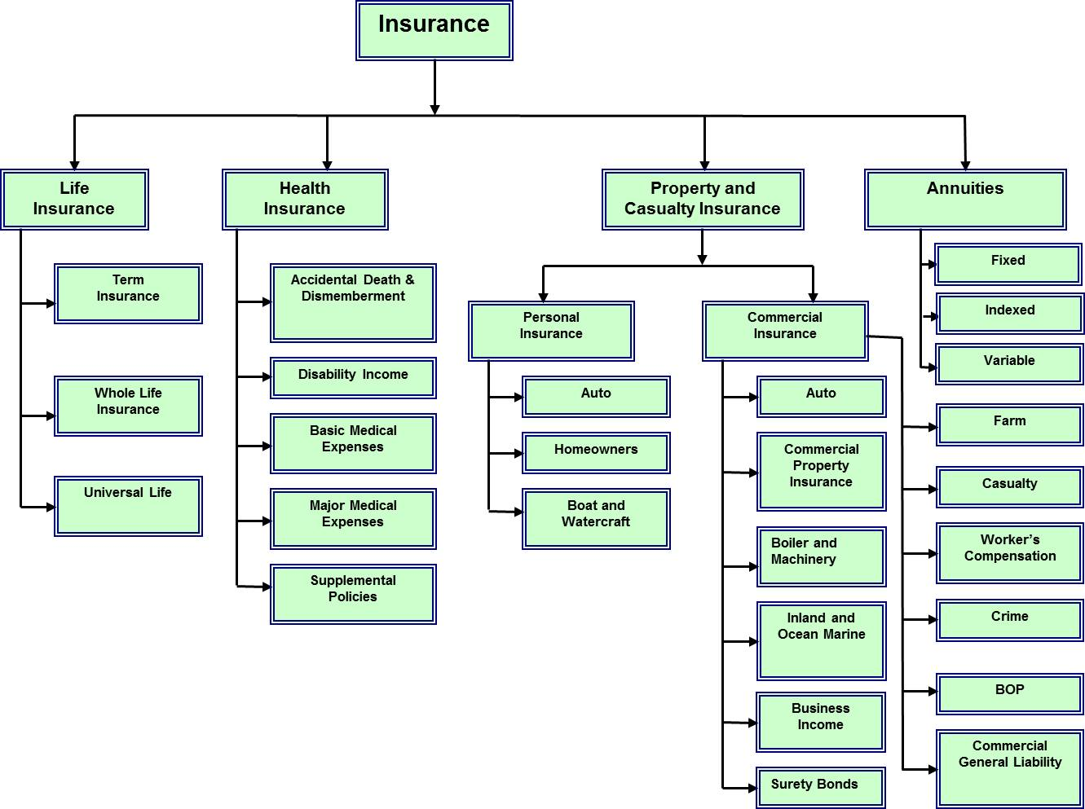

### Life Insurance

Replaces the income-earning potential lost through death and also helps to pay expenses related to an insured's death. No federal income tax on “death benefits”.

Basic types of life insurance

* + - Whole Life Insurance – provides life time protection
    - Term Insurance – provides coverage for specific period
    - Universal Life – combines insurance with savings

### Health Insurance

This insurance takes care of all medical and hospital related costs of an individual.

### Property and Casualty Insurance

Property insurance covers property damage risk. Property damage risk is a risk of economic loss to your automobile, home or other belongings due to accident, theft, fire or natural disaster.

Casualty or Liability insurance covers liability risk which is a risk of economic loss resulting from you being responsible for harming others or their property.

Property and Casualty insurance can be classified as

1. **Personal Insurance:** An individual or personal insurance policy can provide coverage and protection for an individual's personal property unrelated to a business. For instance, an individual insurance policy may incorporate a homeowner's policy, liability insurance and a personal automobile policy. Example – Auto, Homeowners, Boat and Watercraft
2. **Commercial Insurance or Business Insurance:** Business insurance provides coverage for expenses related to the business. These business expenses can result from damages to supplies, equipment, company vehicles and the premises of the company. Example – Auto, Commercial Property, Boiler and Machinery.

### Annuities

An annuity is a contract between you and an insurance company that is designed to meet retirement and other long-range goals, under which you make a lump-sum payment or series of payments. In return, the insurer agrees to make periodic payments to you beginning immediately or at some future date. There are generally three types of annuities — fixed, indexed, and variable.

## The Insurance Policy

* + - An “aleatory contract” (One party provides something of value to another in exchange for a conditional promise. Only if the event occurs promise must be performed. Services can be of unequal values) between an insured and an insurer, who agrees to indemnify the insured for loss caused by specified events.
    - Insurance policy is a complete written contract of insurance.

## Group and Individual Insurance

What is a group insurance?

Group insurance is a single insurance policy that covers a specific group of people. Examples of groups include employees of a company, members of a professional organization, or alumni of a college. Many group policies include dependents of group members.

Group coverage can help reduce the problem of adverse selection by creating a pool of people eligible to purchase insurance that belong to the group for reasons other than for the purposes of obtaining insurance. In other words, people belong to the group not because they possess some high-risk factor which makes them more apt to purchase insurance (thus increasing adverse selection); instead they are in the group for reasons unrelated to insurance, such as all working for a particular employer.

A feature which is sometimes common in group insurance is that the premium cost on an individual basis may not be risk-based. Instead it is the same amount for all the insured persons in the group. So, for example, in the United States, often all employees of an employer receiving health insurance coverage pay the same premium amount for the same coverage regardless of their age or other factors. In contrast, under private individual health insurance coverage in the U.S., different insured persons will pay different premium amounts for the same coverage based on their age, location, pre-existing conditions, etc.

What is individual insurance?

Individual insurance is a single insurance policy that covers one person.

What are the differences between group and individual insurance plans?

Group policies are usually less expensive than individual policies, depending on health. Bigger groups may be given more favorable rates than smaller ones because a few large claims are less likely to wipe out expected profits. More established groups may get better rates than new ones because the insurer has more claims history to rely on. Most group policies guarantee to accept any member of the group. Group policies may provide more benefits. Your choice of services under group policies, however, is limited to what is offered.

Individual health policies are usually more expensive for fewer benefits. Individual policies are usually guaranteed renewable. Qualifying for many life and health insurance plans requires passing a physical exam. Depending on the type insurance, individual plans may enable consumers to tailor the plan to meet their specific needs.

Is there an exception to that rule?

Life insurance and Long-Term Care Insurance are a little bit different. The price of individual life insurance is closely related to a person's age, health, family medical history, and other risk factors such as obesity and smoking. In general, a younger person in great health with few risk factors will be able to purchase life insurance on their own for less than they can get it in a group. As a result, group life policies may have a disproportionately high level of people with higher risk factors. Group life policy rates often have that extra risk built into the rate everyone pays. It is similar for Long-Term Care insurance in which the cost of a policy is based on many things including the individual's age and health at the time of purchase.

Is group insurance only available through an employer?

No. You may be able to get group insurance through a professional organization, an alumni association, or other membership type organization. In some states, a self-employed individual may qualify as a group of one.

## Insurance Organization

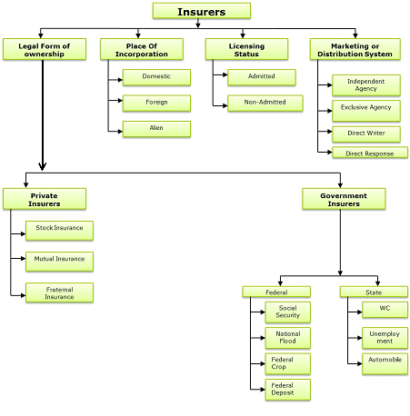

### Ownership Based Classification

1. **Private (non-governmental)**
   * Provides most of the liability and property insurance
   * Also provides some insurance through government sponsored insurance programs
   * Private Insurers can be further classified as
     + **Stock Insurance companies:** Company has stock that is bought by shareholders. These shareholders get dividends.
     + **Mutual Insurance companies:** This type of company is owned by its policy owners. Policy owners receive dividends out of operating profits
     + **Fraternal Benefit companies:** Provided by a society to its members who share a common ethnic, religious etc. background.
2. **Federal Government**
   * Meet specific insurance needs of the public
   * Social Security program
3. **State Government**
   * Meet specific insurance needs of the public
   * Support insurer in case where the insurer is financially unable to meet its obligations

### Place of Incorporation Based Classification

1. **Domestic**
   * An insurer incorporated in the same place in which it is transacting business
2. **Foreign**
   * An insurer licensed to operate in a state but incorporated in another state
3. **Alien**
   * An insurer incorporated in another country

### Licensing status Based Classification

1. **Admitted**

Admitted" insurance companies are those that are licensed and regulated by the state in which they operate. Admitted insurers must file their rates with the state's regulator. Because they have this status, the state will step in to cover claims by insurers in case they go bankrupt. Also, because they are regulated, they may not offer certain types of high-risk insurance.

1. **Non-Admitted or Unlicensed**

"Non-admitted" insurance companies are those that are not licensed or regulated by the state in which they operate. They do not have to file their rates with the state, and therefore may charge whatever amount they like in order to provide insurance coverage. Non-admitted insurance companies exist primarily for the purpose of providing certain types of insurance that are too high of a risk for admitted insurance companies, such as professional liability insurance for doctors, lawyers and others. Similarly, an owner of a large, Oceanside hotel in Florida may not be able to purchase adequate property insurance from an admitted insurer in Florida because the hotel may be located in a known hurricane zone. Therefore, the owner may have to purchase insurance from a non-admitted carrier.

### Marketing or Distribution system Based Classification

1. **Independent agency**

Insurer uses the services of an independent firm that sells insurance as a representative of several unrelated insurance companies.

1. **Exclusive agency**

Insurer uses the services of a firm that sells insurance exclusively for the insurance company or group.

1. **Direct writer**

An insurer that uses the direct writing system to market insurance (they do not depend on individual producers to locate consumers and sell insurance) for only one insurance company or group. But they are not self-employed as in the case of Exclusive Agency.

1. **Direct response**

They use mail, phone and/or internet sales mechanisms to reach the customers.

## Insurance Regulation

### Why regulate

Insurance is regulated primarily for the following three reasons

* **To protect consumers**
* Regulators review policy forms to protect policyholders (set coverage standards, specify policy language and disapprove contracts that do not meet with regulator’s approval).
* They ensure that insurance is readily available, especially those that are viewed as necessities.
* **To maintain insurer solvency**
* To ensure future protection
* Protect interest of a large number of individuals
* Safeguard the substantial sums of money held by insurers
* **To avoid destructive competition**
* Important to maintain prices at a level that ensures solvency
* Make all type of insurance available

### What is regulated

Insurance regulation focuses mostly on the following areas

* **Formation and licensing of insurers**
* Through licenses the state indicates that the insurer meets minimum standards of financial strength, competence and integrity
* Licenses provide membership to insurers to any state funded plans
* **Licensing of insurance personnel**
* State license people who sell insurance, give insurance advice or represent insurers (producers, insurance consultants and claims representatives)
* **Solvency regulation**
* Specify financial requirements
* Review of annual statements
* IRIS ( Insurance Regulatory Information System )
* Field examinations
* **Contract regulation**
* Law may require the use of a standard policy form
* The state law might require prior approval of policy forms
* The insurance contract might be required to meet a certain test of readability
* **Rate regulation**
* State-mandated rates (rates set by state agency)
* Prior approval laws (rates have to be approved by state)
* File-and-use laws (rates have to be filed with state, but they can be used immediately)
* Use-and-file laws (put rate changes into effect and later submit the filing)
* Flex rating laws (prior approval is required only if the new rates exceed a certain percentage above the existing rates)
* Open competition (price driven by market forces)
* **Market conduct**
* Sales practices are regulated to prevent agents and brokers from getting engaged in certain illegal and unethical activities
* Underwriting practice constrains insurers’ ability to accept, modify or decline application, restrict cancellations.
* Prohibit a wide variety of unethical and illegal claim practices
* **Consumer protection**
* Provide a range of information to consumers

### Who regulates

* **Official Regulators**
* Insurance regulatory authority in the U.S. ultimately rests with the federal government, although most operational control of insurance regulation has been ceded to the states. Constitutional authority remains with Federal government. State Government owns primary authority and regulations are made by State Government until the regulation made is adequate. If not, Congress interferes.
* Insurance business is regulated by state insurance departments (SID)
* State regulators are members of National Association of Insurance commissioners (NAIC)
* **Un-Official Regulators**

Financial rating agencies

* Moody’s
* Standard and Poor’s
* Duff and Phelps
* **Insurance advisory organizations**
* ISO
* AAIS
* NCCI
* **Insurer trade organizations**
* **Consumer organizations**
* CFA

## Insurance Process

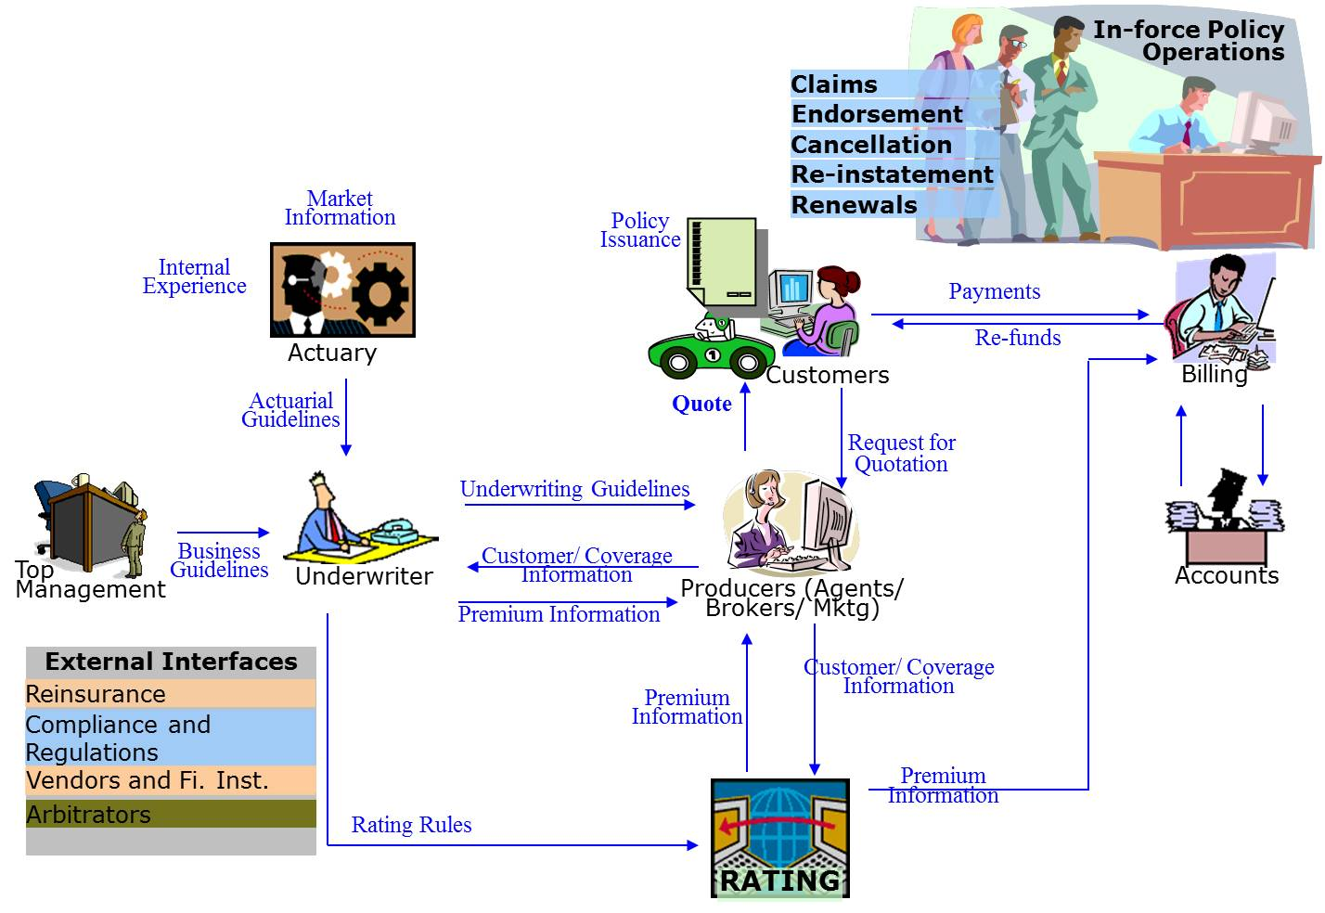

* + - **Actuaries** put price tags on risks. They are basically statisticians who calculate the costs of uncertain future events that range from tornadoes and hurricanes to changes in life expectancy. Actuary determines the rates that should be charged for various types of insurance and for different customers, thus supporting the underwriting function of the company. They study past claims information and make predictions about future losses.
    - **Underwriters** read and analyze insurance applications, ask the right questions to determine the true exposures presented, and determine the appropriate price for insurance based on the exposures of the applicant. Underwriter decides which risk can be insured and which risk to be rejected.

Generally the risk categories that are identified by all underwriting guidelines are:

* **Standard risks**: Proposed insured that have the likelihood of loss that is not significantly greater-than-average. Premium rates that they are charged are **standard premium rates**.
* **Substandard risks**: Proposed insured that have significantly greater –than- average likelihood of loss but are still found insurable. This category is called **special class risks**. Premium rates that they are charged are higher and are called the **substandard premium rate** or **special class rate**.
* **Declined risk**: Proposed insured that are considered to present a risk that is too great for the insurer to cover.
* **Preferred risks / Super Preferred risks**: Proposed insured that present a significantly less-than-average likelihood of loss. They are generally charged a lower than standard premium rate.
  + - **Producers** sell insurance products for an insurance company or companies. Producer obtains customer and coverage information from the customer. The information gets into the insurers system and is used by Underwriters to determine the true risk exposure and the rating engine to determine the premium. A quotation is provided to the customer followed by issuance of policy. The policy is then in-force.
    - **Customer** requests for quotation or buys the insurance policy. People who are involved in the creation and operation of an insurance policy are
* **Applicant**: The person or business that applies for an insurance policy
* **Policy owner**: The person or business that owns the insurance policy
* **Insured**: The person whose life or health is insured under the policy
* **Third-party policy**: When one person purchases insurance on the life of another person
* **Beneficiary**: The person or party the policy owner named to receive the policy benefit
  + - **In-force policy operations:** Once a policy is in-force following operations can take place
* **Claims:** On the occurrence of specified event customer can report claim
* **Endorsement:** Customer can request for changes to the policy like address change
* **Cancellation:** Customer can cancel the policy if he/she no longer wants to continue. A policy is also cancelled due to non-payment of premium.
* **Renewal:** Customer can renew the policy by paying renewal premium.
* **Reinstatement:** If a policy gets lapsed due to non-payment of premium customer can reinstate the policy. There is normally an additional fee required for reinstatement.
  + - **Billing** plays an important role in premium collection and claim payment. Other functionalities include Bills and Statement generation, Non-pay cancellations, Billing adjustments and refunds, inquiries and customer service.

## Importance of Insurance

* Since we cannot predict the future, it is important to protect ourselves and our possessions against damage and harm.
* Insurance is all about protection- it protects us against an unfortunate incident such as a car accident, a robbery, or an illness.
* The moment an unexpected ill-fated event happens, we will be glad that we have insurance. Medical bills from a minor accident can deplete savings and force bankruptcy, such situations could be avoided using insurance
* Insurance in today's context is an essential financial service.
* Basically, there are four areas that most people are concerned about insuring: their life, their health, their possessions, and their finances.

# Chapter 2 - Producer Management

# Producer Management

## Who is a Producer

Insurance business deals with selling policies to the customers. To reach to the end users (customers) Insurance Companies (Carriers) build a distribution channels—individual agents, corporate agents (including Banc assurance) and Brokers. The marketer in the distribution network is in direct interface with the prospect and the customer.

A producer is usually paid a small commission every time you make an insurance premium payment. It is in the producer’s best interest to provide good service and maintain you as his or her client because of this.

The producer’s role is twofold. He or she helps the insurance companies sell their products. He or she also helps educate clients on their insurance product choices, assists in submitting and following up on applications, and providing ongoing service.

## Types of Producer

Listed below are the different types of producers:-

### Insurance Agents

Insurance agents are insurance professionals that serve as an intermediary between the insurance company and the insured. As a broad statement of law, an agent’s liability to their customers is administrative. That is, agents are only responsible for the timely and accurate processing of forms, premiums, and paperwork. Agents have no duty to conduct a thorough examination of your business or to make sure you have appropriate coverage. Rather, it is your obligation to make sure you have purchased needed coverage.

Insurance agents can be either of the below categories:

**Captive / Exclusive** – A captive / Exclusive agent is an agent who works for only one company and is a “captive” of that company. A captive agent will sell policies only for that insurer. A captive agent is paid by that one company either with a combination of salary and commissions or with just commissions. He or she may be a full-time employee or an independent contractor, and may be provided with office space and benefits by the employer. Captive agents have in-depth knowledge of their particular company’s insurance products, but cannot help a client who does not need or does not qualify for that company's products. The parent company may push its captive agents to sell certain policies or meet certain sales quotas.

**Independent Agents** – The opposite of a captive agent is an independent agent. An independent agent does not work for any particular insurance company and is often paid by commission only. Independent agents can sell policies from an array of companies. This arrangement can be better for clients because the agent can seek out the best policy for that client’s needs. However, an independent agent may not have specialized knowledge about a particular company's products. An independent agent arrangement can be better for agents because it offers a more diversified source of income, but it can also be riskier because the agent may need to provide his or her own startup capital, pay for business expenses and arrange benefits. In addition to insurance policies, agents often sell [mutual funds](http://en.wikipedia.org/wiki/Mutual_funds), [annuities](http://en.wikipedia.org/wiki/Annuity_(US_financial_products)), and products that address wealth management, [retirement](http://en.wikipedia.org/wiki/Retirement) and [estate planning](http://en.wikipedia.org/wiki/Estate_planning).

### Corporate Agents

Corporate entities represent an insurance company and sell its policies. Usually they are engaged in a particular business and sell insurance policies to their existing customers based on the situation. For example, a travel agent may offer you a travel insurance policy or a vehicle dealer a motor insurance policy. When a bank becomes the corporate agent of an insurance company it is referred to as a banc assurance arrangement or partnership. Banks offer insurance policies to their customers based on their knowledge of their situation and needs.

### Insurance Brokers

Insurance brokers can be best described as a kind of super-independent agent. Brokers can offer a whole host of insurance products for you to consider. Brokers are required to have a broker’s license which typically means the broker will have more education or experience than an agent.

Brokers also have a higher duty, in most states, to their clients. Brokers have the duty to analyze a business and secure correct and adequate coverage for the business. This is a higher duty than the pure administrative duty of the agent. However, this expertise comes at a price. Brokers typically charge an administrative fee or premium payments are higher when purchased through a broker.

### Insurance Agencies

Insurance Companies deals with Insurance Agencies as well, to market and sell their products. Insurance Agencies are organizations which are licensed by the State Government Bodies to sell insurance Products. Insurance Agencies work with different Insurance Carriers. Agencies constitute of agents who sell the products and educates the customers about the different products launched by different carriers. There are different types of Agencies:-

General Agency

A General Agency (commonly referred to as a GA) is an insurance agency which partners with various insurance carriers to market and distribute their products to *agents and brokers*. They are an expert on various product portfolios, underwriting guidelines, eligibility, rates, and all other relevant carrier information. A General Agency is led by a General Agent.

#### General Agent

Individual responsible for insurance agency operation in a particular area, including sale of life and health insurance, servicing policies already sold, recruiting and training agents, and providing administrative support. A General Agent is normally compensated by the carrier in the form of an override on business sold through the GA. The general agency method is a cost-effective distribution system since the carrier does not have to pay for any of the services unless a policy is sold and placed through the general agency. This override is completely separate from the agent’s commission. The writing agent is the broker of record on the case and receives full commission.

Brokerage General Agency

A brokerage general agency (BGA) is an organization that contracts with multiple insurance companies. The agency then contracts with individual agents who go through the agency for access to the life insurance carrier's product. BGAs are independent – not owned or controlled by the insurance carriers. Their primary business is wholesaling of insurance. The BGA can specialize in one segment of the insurance industry or sell policies across a wide range of insurance products. Many insurance carriers will not establish direct contracts with individual brokers, requiring individual advisors to work through a BGA. The BGA works together with the advisor for a common goal: to get the best possible insurance solutions for their clients. By aggregating the production of the producers in its agency, the brokerage general agency can then negotiate a higher pay out for its agents.

Broker Dealer

A person or firm in the business of buying and selling securities, operating as both a broker and a dealer depending on the transaction. A broker is only an agent who executes orders on behalf of clients, whereas a dealer acts as a principal and trades for his or her own account. Because most brokerages act as both brokers and principals, the term broker-dealer is commonly used to describe them. A broker dealer provides the securities and also arranges and executes transactions for others to buy and sell those securities for their own accounts. Insurance broker dealers work with securities that are designed for insurance products. Variable annuities and variable universal life insurance both invest a portion of the customers' premiums into securities that look and act like, though legally are not, mutual funds. Insurance broker dealers originate and manage these securities on behalf of their clients.

## Producer Eligibility

An insurance producer (also called an agent or insurance broker) is an individual licensed by a State's Insurance Division or Department to sell insurance in that State. There are different categories of insurance and a producer must be licensed in each category he or she wishes to transact business. Health Insurance is one such category. An initial course of instruction is required, an insurance licensing exam must be successfully passed, and all licensing fees must be paid before an individual becomes a producer and can conduct insurance business. The license must be renewed on a regular basis and requires completing several hours of continuing education courses on ethics, law, and product knowledge.

An insurance producer must also be appointed by at least one insurance company to transact business on its behalf. He or she may be appointed with several insurance companies.

## Types of Licenses

**The National Association Insurance Commissioner (NAIC)** Producer Licensing Model Act requires producers to hold an insurance license in the state in which the solicitation, sale or negotiation takes place prior to the actual sales activity. A license is an authorization issued by the department of Insurance to a producer to conduct insurance business. Separate license is required for each state in which business will be done and for each line of business. Insurance Company, Agency and Agent must all be licensed with the State Department of Insurance.

### Insurance Producer

A general insurance producer is any individual, corporation, association, partnership, limited liability company, limited liability partnership or other legal entity who or which sells, solicits, negotiates or procures products of different carriers for the following lines of business:-

* + Life
  + Accident, and Health
  + Property
  + Casualty
  + Personal Lines
  + Variable Life and Variable Annuity Products

### Surplus Lines Insurance Producer

A surplus lines insurance producer is any individual, corporation, association, partnership, limited liability company, limited liability partnership or other legal entity who or which sells, solicits, negotiates or procures insurance business from an insurance company not licensed to transact business in a state.

### Limited Lines Producer

A limited lines producer is an individual corporation, association, partnership, limited liability Company, limited liability partnership, or other legal entity which sells, solicits or negotiates one of the following limited lines: travel accident, travel baggage, prearranged funeral, crop hail, credit, title, or similar limited lines allowed by the Commissioner.

* + Industrial Fire
  + Industrial, Life, Accident, and Health
  + Surety
  + Title
  + Trip, Accident and Baggage
  + Car Rental
  + Crop
  + Travel

### Limited Lines Credit Producer

A Limited Lines Credit Producer is an individual whose duties only include selling, soliciting or negotiation of limited lines credit insurance. Each producer must complete an approved program of instruction for Credit Insurance. It is the sponsoring insurer's responsibility to provide the program of instruction and to have the program approved by the Commissioner.

### Consultant

A **consultant** is an individual, corporation, limited liability company, association, partnership or other legal entity who or which, for a fee holds himself or itself out to the public as engaged in the business of offering any advice, counsel, opinion or service with respect to the benefits, advantages or disadvantages promised under any policy of insurance that could be issued in this state.

Consultants may not continue to hold an insurance producer or limited lines producer license, once licensed as a consultant. No licensed consultant may employ, be employed by, be in a partnership with or receive any remuneration whatsoever from any licensed insurance producer, surplus lines insurance producer, limited lines producer or insurer, except that a consultant may be compensated by an insurer for providing consulting services to the insurer. No consultant license is required for the following:

* Attorneys licensed to practice law in Indiana acting in their professional capacity
* A duly licensed insurance producer or surplus lines insurance producer
* A trust officer of a bank acing in the normal course of his/her employment
* An actuary or a certified public accountant that provides information, recommendations, advice or services in her/his professional capacity.

Prior to rendering any service, a consultant must submit for the commissioner's approval the written agreement intended for use.

## Regulatory Bodies

There are various regulatory bodies in USA to regulate the producers and safeguard the interest of the consumers.

### NAIC

The National Association of Insurance Commissioners (NAIC) has a significant role in the regulation of insurance activities in the U.S. With time, the scope of its purposes has expanded so that its primary objectives are (1) the maintenance and improvement of state regulation, (2) the maintenance of a financially secure and healthy insurance industry, and (3) the promotion of fair treatment of policyholders and claimants.

### NIPR

NIPR is a unique public-private partnership that supports the work of the states and the NAIC in making the producer-licensing process more cost-effective, streamlined and uniform for the benefit of regulators,

The National Insurance Producer Registry (NIPR) is a non-profit affiliate of the National Association of Insurance Commissioners (NAIC). NIPR, with collaboration from Authorized Business Partners like **Sircon**, developed and implemented the **Producer Database** (**PDB**) and the NIPR Gateway suite of on-line products for the insurance industry including Appointments and Terminations, Non-Resident Licensing, Non-Resident Licensing Renewals and other electronic reporting tools to support the Producer Licensing process. NIPR is governed by a 13 member board of directors, with 6 members representing the NAIC, 6 industry trade association representatives, including 3 producer trades and the CEO of the NAIC as an ex-officio voting board member.

The PDB is an electronic database consisting of information relating to insurance agents and brokers (producers). The PDB links participating state regulatory licensing systems into one common repository of producer information. The PDB also includes data from the Regulatory Information Retrieval System (RIRS) to provide a more comprehensive producer profile.

The NIPR Gateway is a communication network that links state insurance regulators with the entities they regulate to facilitate the electronic exchange of producer information. Data standards have been developed for the exchange of license application, license renewal, and appointment and termination information.

### State Insurance Departments

State insurance commissioners are charged with protecting the interests of consumers in their states and typically respond with laws that regulate insurer investments, charter licensing, policy contracts, and accounting procedures.

### DTCC

**The Depository Trust & Clearing Corporation** (DTCC) provides clearance, settlement, and information services for equities, corporate and municipal bonds, unit investment trusts, government and mortgage-backed securities, money market instruments, and over-the-counter derivatives. It also manages transactions between mutual funds and insurance carriers and their respective investors. It was set up to provide an efficient and safe way for buyers and sellers of securities to make their exchange, and thus "clear and settle" transactions.

### NSCC

National Securities Clearing Corporations(NSCC) is the original clearing corporation, it provides clearing and serves as the central counterparty for trades in the US securities markets.

Provides clearing, settlement, risk management, central counterparty services, and a guarantee of completion for certain transactions for virtually all broker-to-broker trades involving equities, corporate and municipal debt, American depositary receipts, exchange-traded funds, and unit investment trusts. NSCC also nets trades and payments among its participants, reducing the value of securities and payments that need to be exchanged by an average of 98% each day. NSCC generally clears and settles trades on a "T+3" basis. NSCC has roughly 4,000 participants, and is regulated by the U.S. Securities and Exchange Commission (SEC).

### SEC

The **U.S. Securities and Exchange Commission** (frequently abbreviated **SEC**) is a federal agency which holds primary responsibility for enforcing the federal securities laws and regulating the securities industry, the nation's stock and options exchanges, and other electronic securities markets in the United States. In addition to the Securities Exchange Act of 1934 that created it, the SEC enforces the Securities Act of 1933, the Trust Indenture Act of 1939, the Investment Company Act of 1940, the Investment Advisers Act of 1940, the Sarbanes–Oxley Act of 2002 and other statutes.

## How to become an Insurance Agent

### Independent Agent

* **To become an Independent Insurance Agent** research the state's requirements for becoming an independent insurance agent. Insurance requirements vary by state. On average, agents must be at least 18 years of age. Furthermore, they must live in the state where they seek a license.
* Obtain a degree from a college or university. Although a college degree isn't required to become an insurance agent, several independent agencies prefer candidates with a degree. Insurance agents typically receive a degree in business or economics.
* Choose a type of insurance to sell. Independent insurance agents have their choice of insurances, which include health, life and automobile. Agents can specialize in a particular type of insurance or offer a range of products.
* Complete a licensing course and take the insurance examination. Before an independent agent can sell insurance in a particular state, they need to complete a state-approved licensing course and successfully pass the state insurance examination.
* Decide whether to buy a franchise or become affiliated with an insurance agency. Independent insurance agents can purchase their own franchise, which generally costs between $50,000 and $75,000. Another option involves becoming affiliated with an insurance agency and working as an independent agent. Independent agents can open their own location or run their business from home.

### Captive Agent

A captive insurance agent is a person licensed to sell various types of insurance from one particular insurance company. Generally, a company will train and provide resources to help this person build his business. Because this company is putting in the time and money to help the agent, the agent may only sell preapproved products from this company.

* **To become a Captive Agent** contact the particular agency you wish to work with. Some of the largest insurance companies in the United States include Farmer's Insurance, Primerica, New York Life and Geico. Some specialize in particular types of insurance such as life, auto and/or property. Most insurance companies are always hiring, since agents are paid on commission. If you make the company money, you'll get paid as well. A company has nothing to lose by hiring more and more agents. However, different companies have various benefits and hiring practices. Some will pay for your licensing, others don't. After researching the best company for you, contact a local agent to begin the hiring process.
* Visit the local agent or the human resources manager for the first interview. The employer will want to know about past sales experience and your communication and relationship-building skills. You must be able to study and pass several state exams. Be sure to have a professional-looking resume and possible references that can attest to your work ethic. Some companies have sales quotas you must fulfill in order to remain an agent. Other companies make you a captive agent for a certain time, and then allow you to become independent. Be sure you understand company requirements and the employment timeline before you apply.
* Submit your application to the company, once the HR manager has determined that you would make a good agent. There will be a background check to ensure you do not have prior felonies or any type of financial improprieties. Particular legal requirements to become an insurance agent vary by state. Discuss honestly any background information that may affect your ability to qualify as an agent. There may be ways to seal a record or have prior charges reduced.
* Attend the pre licensing classes most companies offer. Some have in-person or online classes. After the classes, you should be eligible to take a state exam in life, health, property or whatever type of insurance for which you are applying. Once you pass, you will be appointed in a junior position and begin field training to sell insurance. You are considered a captive agent since you are only allowed to sell products of which the company approves.
* Complete the field training and the continuous education that most companies require. This may take a year or more. Once the company feels that you are a capable salesperson, they may increase your commission and/or give you more independence such as giving you an office to manage.

## Producer On-Boarding

A producer has to be on boarded by the carrier to make them eligible to sell a particular carriers product.

Producer On boarding process consists of certain actions

* Licensing by the State Insurance Department
* Appointment by the Carrier
* Contract (mutual agreement between the Carrier and the Producer)

Producer on boarding process is initiated based on certain factors like

* New Product launch
* Inclusion of new territory
* Market expansion
* Type of producers needed (captive/ independent)

Based on the above mentioned needs carriers float notice for new recruitment of producers. After they receive interested producer application, carriers go for license validation (for independent agents). For captive agents, carriers sponsor the license. Next is appointment which the carrier provides to the producer based on a particular license from a particular State department on a particular Line of Business.

Once the appointment is given to the producer, Carrier signs a contract with the producer which list the incentive package the producer would get selling the insurance carrier’s products. The contract also holds the hierarchy details for that producer - both compensation and reporting.

Producer on boarding process is depicted in the below diagram.

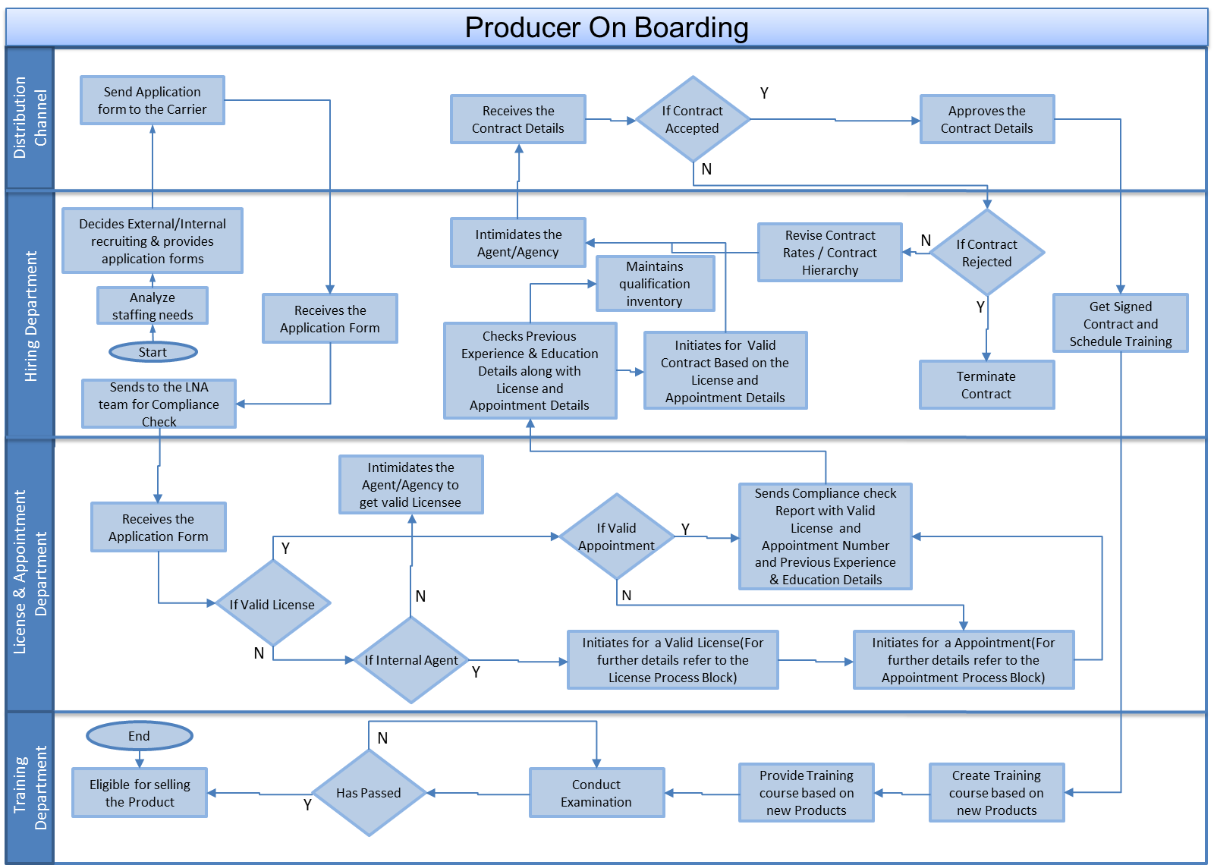

LNA Team – License and Appointment team

## Producer Licensing

**Participants:**

* Distribution Channel (Agents, Agency)
* Carrier
* State insurance Department
* NSCC (optional)

**Actions:**

* License Issue
* License Renewal
* License Termination

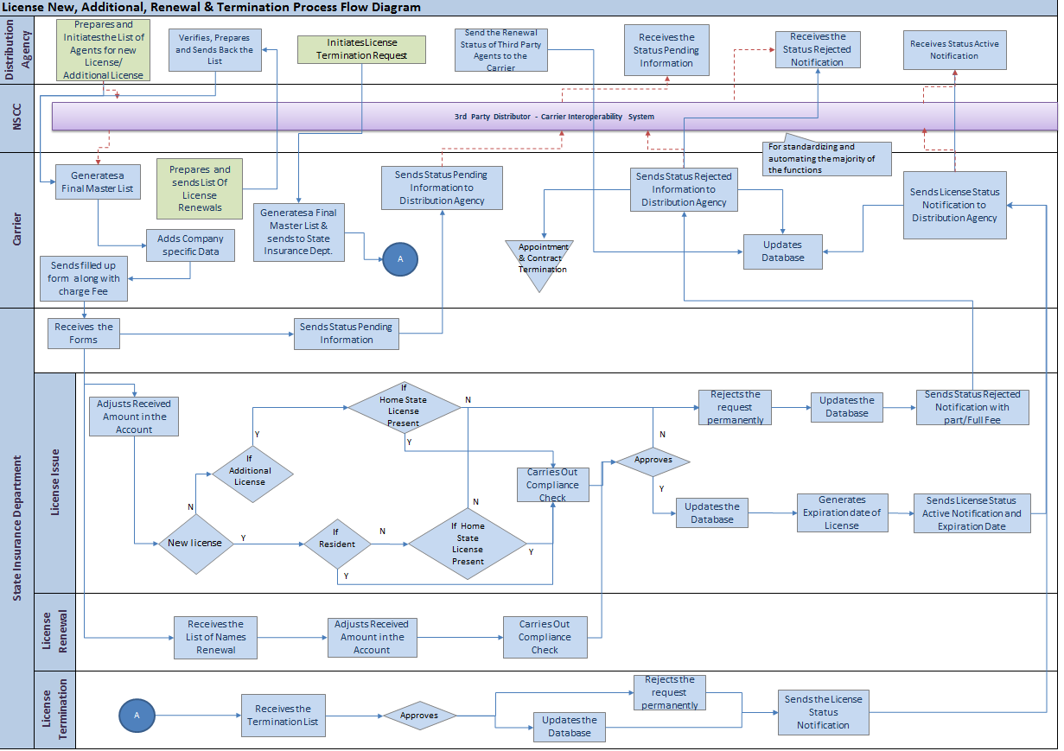

### License Issue through an Insurance Carrier

**Step 1:**

**Participant: -** Distribution Channel (Agency)

**Action:-**

Prepares and Initiates the List of Agents for new License/ Additional License and sends it across to the Carrier for sponsorship.

The information typically sent to the carrier for license request is:-

* + Demographic Details
  + Jurisdiction *(e.g. Alabama)*
  + License Line *(e.g. Life)*
  + License Type *(e.g. corporation)*
  + Resident Status *(e.g. Non-resident)*
  + Background verification details (e.g. continuing education, code of conduct etc.)

This action can be performed in two ways:-

1. Directly sending the list to the Carrier
2. Using a 3rd Party Distributor - Carrier Interoperability System (NSCC)

NSCC – It helps multiple distributor to connect to a carrier and send data appointment requests and appointment terminations, producer terminations, address changes, rep ID number changes and license confirmations.

**Step 2:**

**Participant:** Carrier

**Action:**

Carrier License and Appointment (LNA) Department generates a master list of all the applications for New License application and adds company specific data to it.

Information typically added by the carrier is:-

* + Sponsor (Carrier Name)
  + Sponsorship Details (carrier details like license details from NAIC)
  + Sponsor Date

Carrier then sends the filled up form to the State Insurance Department along with charge fee.

**Step 3:**

**Participant:**  State insurance Department

**Action:**

State Insurance Department (SID) on receiving the entire License issue list from the Carrier adjusts the sponsorship amount as per the licensing cost.

SID provides license to the producers based on certain inputs from the Producer as well as the Carrier.

* Jurisdiction
* Lines of Business
* Additional License

The Producer applying for a license has to abide by certain conditions these are as follows:-

* New License:-
  + Is the producer a resident of that state for which he/she has applied for?
  + If not the producer has to have a License for a particular LOB in his/her Home state.
* Additional License:-
  + If not the producer has to have a License for that particular LOB in his/her Home state.

After all the checks are completed the SID sends the applications for compliance check.

Once the compliance check is done

* If license approved:-
  + Updates NIPR and updates the Producer Database.
  + Intimidates the carrier and declares the Renewal date.
* If license rejected: -
  + Rejects the license request permanently
  + Sends status rejected notification to the carrier with part/Full Fee

**Step 4:**

**Participant:**  Carrier

**Action:**

Carrier on receiving the license acceptance or rejection notification updates its own database and informs the Distribution channel (in this case Agency) about the status.

### License Renewal

**Step 1:**

**Participant:** Carrier

**Action:-**

Carrier generates a list of producers, for whom license is about to get terminated and renewal is necessary within a certain span of time. Carrier then sends the list to the different agencies for which the agents are working for.

**Step 2:**

**Participant:** Distribution

**Action:**

The Agencies on getting notified by the carrier, verifies the list and send the list of producers for whom they want to renew the licenses.

**Step 3:**

**Participant:** Carrier

**Action:**

Carrier LNA Department generates a master list of all the producers for whom License Renewal application will be sent to the SID.

Carrier then sends the filled up form to the State Insurance Department along with charge fee.

**Step 4:**

**Participant:** State Insurance Department

**Action:**

SID sends the applications for compliance check.

Once the compliance check is done

* If license renewal approved:-
  + Updates NIPR and updates the Producer Database.
  + Intimidates the carrier and declares the Renewal date.
* If license rejected: -
  + Rejects the license request permanently

Sends status rejected notification to the carrier with part/Full Fee.

**Step 5:**

**Participant:**  Carrier

**Action:**

Carrier on receiving the license acceptance or rejection notification updates its own database and informs the Distribution channel (in this case Agency) about the status.

Carrier also updates its database on receiving updates from the Independent Agents who does their licensing renewal on their own.

### License Termination

**Step 1:**

**Participant: -** Distribution Channel (Agency)

**Action:**

Prepares and Initiates the List of Agents for termination of License and sends it across to the Carrier for further course of action.

**Step 2:**

**Participant:** Carrier

**Action:**

Carrier LNA Department generates a master list of all the producers for whom License Termination application will be sent to the SID.

Carrier then sends the filled up form to the State Insurance Department along with charge fee.

**Step 3:**

**Participant: -** State Insurance Department

**Action:-**

SID approves the termination of licenses and updates the Producer database and sends the status to the carrier.

**Step 4: -**

**Participant: -** Carrier

**Action:-**

Carrier on receiving the license termination approval notification updates its own database and informs the Distribution channel (in this case Agency) about the status.

## Producer Appointing

Before an agent can represent an insurance company for the solicitation or sale of an insurance product, the Company must appoint the agent who holds a valid license for that LOB in that state. Any producer acting on behalf of an insurer must be appointed by the insurer. An appointment is an authorization from an insurance carrier permitting the appointee to sell the products of that particular carrier. Some states require distribution agencies also to be appointed by the insurer carriers. The Insurance Company appointing an insurance producer in the state shall have to file with the commissioner the appointment, specifying the kinds of insurance to be transacted by the insurance producer.

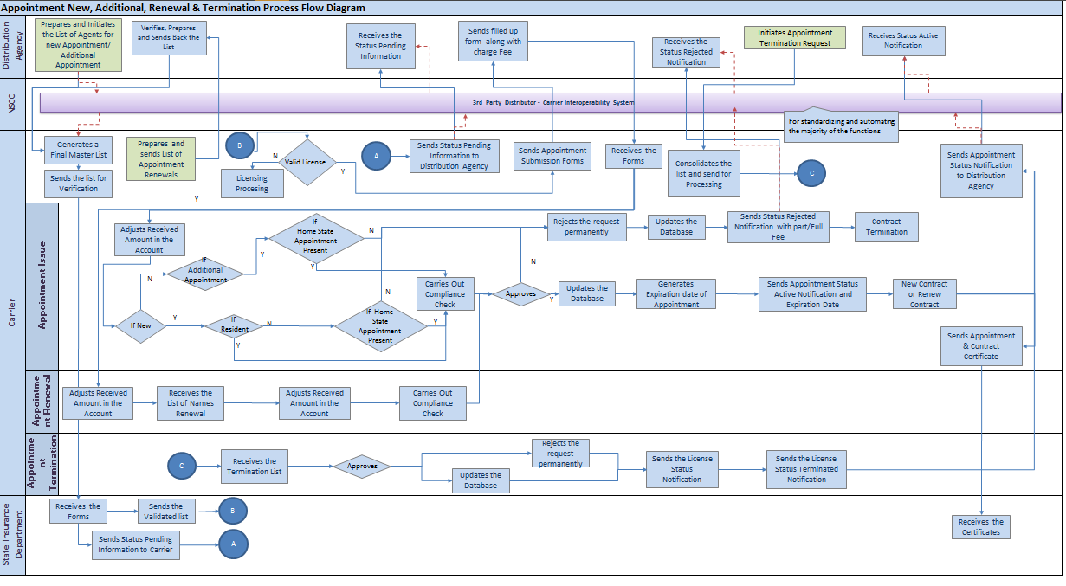

### New Appointment

**Step 1:-**

**Participant: -** Distribution Channel (Agency)

**Action:-**

Prepares and Initiates the List of Agents for new Appointment/ Additional Appointment and sends it across to the Carrier.

The information typically sent to the carrier for appointment request is:-

* + Demographic Details
  + Jurisdiction *(e.g. Alabama)*
  + License details (e.g. License number, termination date, license status etc.)
  + License Line *(e.g. Life)*
  + License Type *(e.g. corporation)*
  + Resident Status *(e.g. Non-resident)*
  + Background verification details (e.g. continuing education, code of conduct etc.)

This action can be performed in two ways:-

1. Directly sending the list to the Carrier
2. Using a 3rd Party Distributor - Carrier Interoperability System (NSCC)

NSCC – It helps multiple distributor to connect to a carrier and send data appointment requests and appointment terminations, producer terminations, address changes, rep ID number changes and license confirmations.

**Step 2:-**

**Participant: -** Carrier

**Action:-**

Carrier License and Appointment (LNA) Department generates a master list of all the applications received for appointment and sends for license verification to the SID.

**Step 3:-**

**Participant: -** SID

**Action:-**

SID verifies the list and sends it back to the carrier.

**Step 4:-**

**Participant: -** Carrier

**Action:-**

Carrier LNA department on receiving the entire Appointment issue verification list from the SID, adjusts the sponsorship amount as per the appointment cost.

Carrier provides appointment to the producers based on certain inputs from the Producer as well as the Carrier.

* Jurisdiction
* Lines of Business
* Additional Appointment

The Producer applying for an appointment has to abide by certain conditions these are as follows:-

* New Appointment:-
  + Is the producer a resident of that state for which he/she has applied for?
  + If not the producer has to have an Appointment for a particular LOB in his/her Home state.
* Additional Appointment:-
  + If not the producer has to have an Appointment for that particular LOB in his/her Home state.

After all the checks are completed the Carrier sends the applications for compliance check.

Once the compliance check is done

* If appointment approved:-
  + Updates Producer management application Database.
  + Intimidates the agency and declares the Renewal date.
  + Intimidates the contracting department for a new contract based on the appointment details.
* If appointment rejected: -
  + Rejects the appointment request permanently.
  + Sends status rejected notification to the agency with part/Full Fee.
  + Terminates the contracting procedure and intimidates the contracting department.

### Appointment Renewal

**Step 1:-**

**Participant: -** Carrier

**Action:-**

Carrier generates a list of producers, for whom appointment is about to get terminated and renewal is necessary within a certain span of time. Carrier then sends the list to the different agencies for which the agents are working for.

**Step 2:-**

**Participant: -** Distribution

**Action:-**

The Agencies on getting notified by the carrier, verifies the list and send the list of producers for whom they want to renew the appointments with the carrier.

**Step 3:-**

**Participant: -** Carrier

**Action:-**

Carrier LNA Department generates a master list of all the producers for whom Appointment Renewal application will be done.

Carrier sends the applications for compliance check.

Once the compliance check is done

* If appointment approved:-
  + Updates Producer management application Database
  + Intimidates the agency and declares the Renewal date
  + Intimidates the contracting department for a contract renewal based on the appointment details
* If appointment rejected: -
  + Rejects the appointment request permanently
  + Sends status rejected notification to the agency with part/Full Fee
  + Terminates the contracting procedure and intimidates the contracting department

### Appointment Termination

**Step 1:-**

**Participant: -** Distribution Channel (Agency)

**Action:-**

Prepares and Initiates the List of Agents for termination of Appointment and sends it across to the Carrier for further course of action.

**Step 2:-**

**Participant: -** Carrier

**Action:-**

Carrier LNA Department generates a master list of all the producers for whom Appointment Termination application will be done.

Carrier approves the termination of licenses and updates the Producer management application database, sends the status to the agency. It also intimidates the contracting department and terminates the contract as well.

## Producer Contracting

Contracts are agreements created between a financial services company and a party that is selling its products. Each contract is associated with a contract kit and specialized for the parties participating in the agreement.

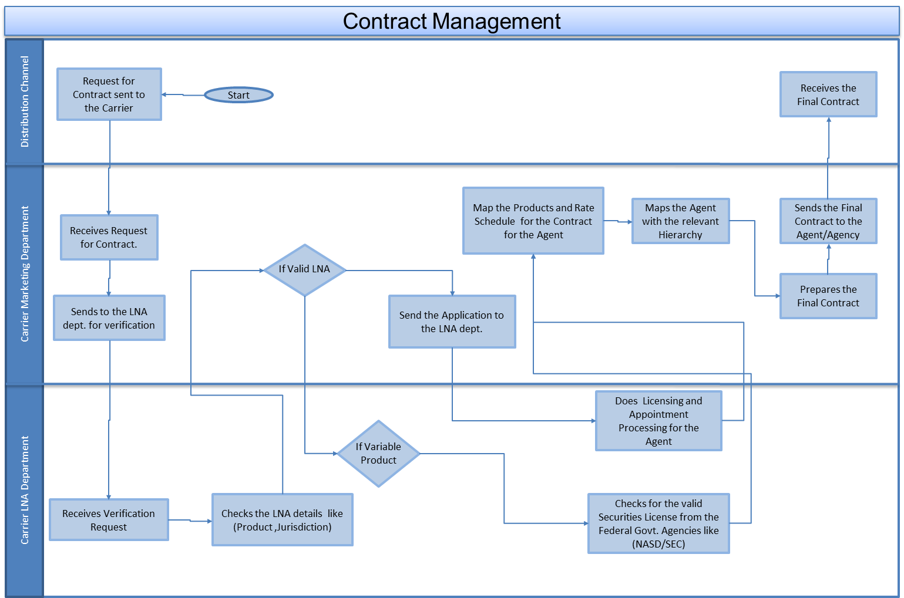

Contract Kits are templates from which individual agreements between a financial institution and distributors are created.

Contract Kits specify:

* + To which products compensation applies (Product Hierarchy, Products)
  + How credit for a transaction is allocated to producers (General Allocation Rules)
  + What performance information is tracked (Quotas)
  + What compensation is paid to participants (Compensation Components; Commissions, Bonuses, Direct Payments)
  + What is the compensation hierarchy
  + What is the payment frequency

Based on the contract details a producer is paid his/her incentive.

## Organization Hierarchy

A hierarchical organization is an organizational structure where every entity in the organization, except one, is subordinates to a single other entity. This arrangement is a form of a hierarchy. In an organization, the hierarchy usually consists of a singular/group of power at the top with subsequent levels of power beneath them.

There are two type of hierarchy

* **Compensation hierarchy** – Compensation hierarchies determine how credit/incentive is rolled up for sales transactions.
* **Reporting Hierarchy** – Reporting hierarchies allow the administrator to set up relationships for reporting purposes.

The figure below shows the reporting and compensation hierarchy in an organization.

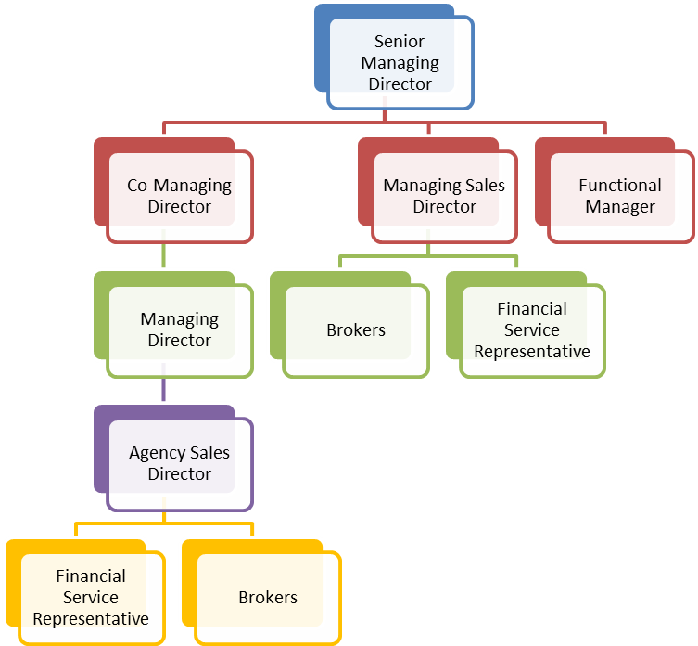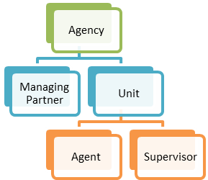

**Compensation Hierarchy**

**Reporting**

**Hierarchy**

## Producer Management System

* producer management system to streamline producer processing, approval and license verification
* producer management system to streamline producer processing, approval and license verification
* producer management system to streamline producer processing, approval and license verification

A producer management system helps to streamline producer processing, licensing, appointment, contract management, training and incentivizing producers. The producer management system also helps to monitor and measure agent performance and compliance.

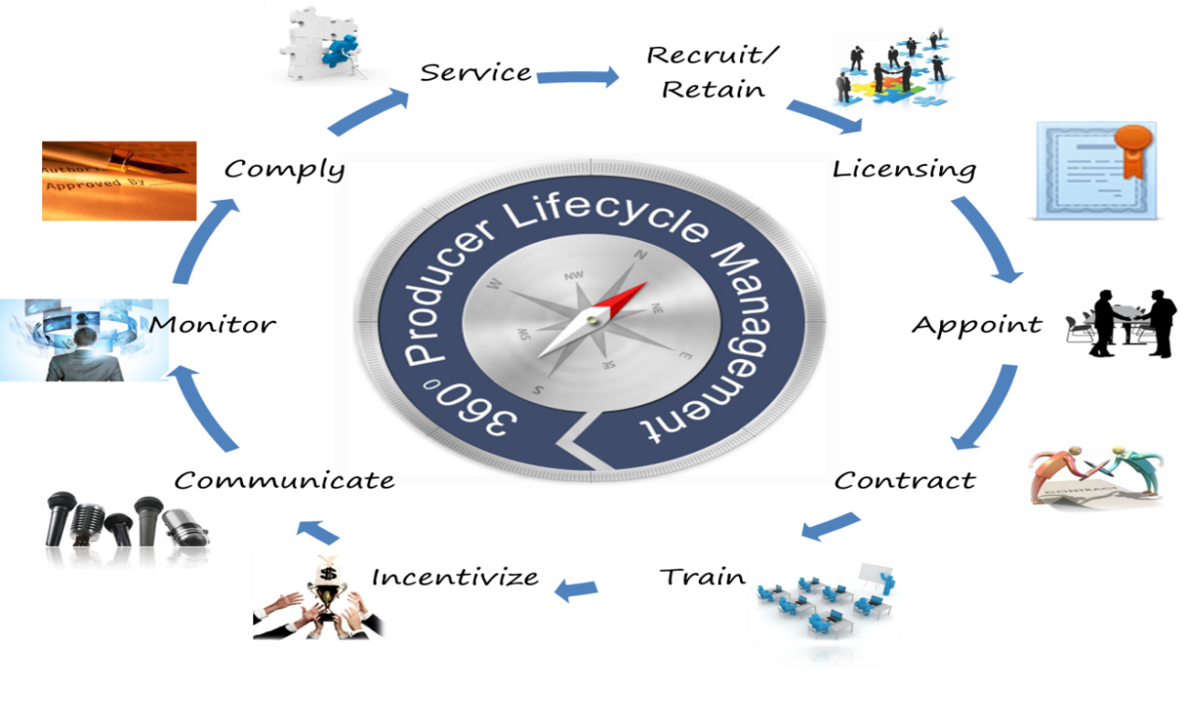

Producer Demographics

Information typically stored in the Producer Repository in producer management system for each agent/agency is shown below:

Producer License

Information typically stored in the licensing system for each agent/agency is shown below

Licensing system is queried with the agent’s ID/profile name, license number, State or Jurisdiction, Product type and effective transaction date to check whether the agent has valid license as on the effective transaction date for that line of business in the particular state where she sold the policy

Producer Contract

Contracts are specific to carriers; an agent can have different contracts with different carriers. Information typically stored in the contract system for each agent/agency is shown below -

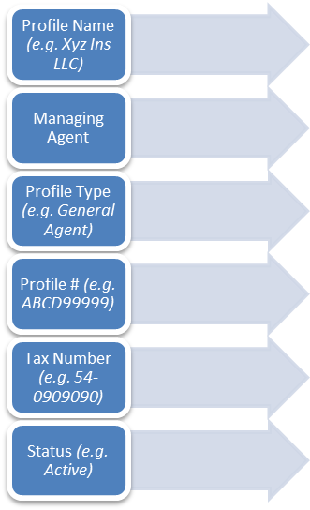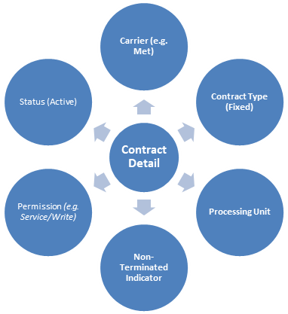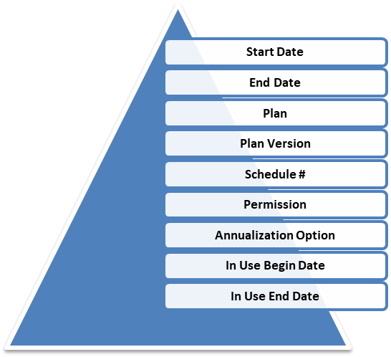

**Agent/Agency Identifier**

**Contract Identifier**

**Contract details**

# Chapter 3 - Incentive Compensation Management

# Compensation Management

**Compensation** is the remuneration received by an employee in return for their contribution to the organization. It is an organized practice that involves balancing the work-employee relation by providing monetary and non-monetary benefits to employees.

Insurance sales agents help insurance companies generate new business by contacting potential customers and selling one or more types of insurance.

The fair compensation system will help in the following:

* An ideal compensation system will have positive impact on the efficiency and results produced by employees. It will encourage the employees to perform better and achieve the standards fixed.
* It will raise the morale, efficiency and cooperation among the workers. It, being just and fair would provide satisfaction to the workers.
* It should motivate and encouragement those who perform better and should provide opportunities for those who wish to excel.
* It aims at creating a healthy competition among them and encourages employees to work hard and efficiently.
* The system provides growth and advancement opportunities to the deserving employees.
* The perfect compensation system provides platform for happy and satisfied workforce. This minimizes the labor turnover. The organization enjoys the stability.
* The organization is able to retain the best talent by providing them adequate compensation thereby stopping them from switching over to another job.
* The business organization can think of expansion and growth if it has the support of skillful, talented and happy workforce.
* The sound compensation system is hallmark of organization’s success and prosperity. The success and stability of organization is measured with pay-package it provides to its employees.

An agent explains various insurance policies and helps clients choose plans that suit them.

## Types of Compensation

Compensation provided to employees can direct in the form of monetary benefits and/or indirect in the form of non-monetary benefits known as perks, time off, etc. Compensation does not include only salary but it is the sum total of all rewards and allowances provided to the employees in return for their services. If the compensation offered is effectively managed, it contributes to high organizational productivity. Compensation is also provided to non-employees like independent agents, brokers, etc. mostly in the form of commission and rewards.

### Compensation Classification – Direct and Indirect

**Direct Compensation**

Direct compensation refers to monetary benefits offered and provided to employees in return of the services they provide to the organization. The monetary benefits include basic salary, house rent allowance, conveyance, leave travel allowance, medical reimbursements, special allowances, bonus, Pf/Gratuity, etc. They are given at a regular interval at a definite time.

**Base Salary**

Base salary is the fixed amount of money paid to an employee by an employer in return for work performed. Base salary does not include benefits, bonuses or any other potential compensation from an employer. Base salary is paid, most frequently, in a bi-weekly paycheck.

**Commission**

Commissions are paid to the agents based on the business they source to the insurance company. The commission rate is based on state regulations or based on market rates. In insurance industry commissions are generally paid as a percentage of the policy premium. Example:- commission paid on first year policy premium is known as first year commission (FYC) and commission paid for renewal year policy premium is known as renewal year commission (RYC).

**Bonus**

The term “bonus” refers to extra pay due to a good performance. In most large organizations, bonuses are being paid to the sales and key management personnel instead of commissions. Typically, the company plan for the year includes both sales and production targets. The bonus system rewards participants with extra payments for those who exceed or far exceed the plan.

* When a bonus plan is in place, participants often have **low average base salaries** and then receive extra compensation from the bonus system. Of course, in a bad year, payments can be minimal.
* A commission system differs in that it is usually not capped. A commissioned sales person can continue increasing his income every time he gets a new order. A bonus system effectively caps the compensation system. Most know that once they max the bonus, they have little incentive to excel. Hence, holding business to the next quarter or bonus period becomes a strategy to maximize bonus.

Some bonus plans include trap doors and trip wires. Your bonus can be cancelled under certain circumstances. For example, if you meet or exceed the plan, but your business sector does not meet its profit target, you get no bonus.

**House Rent Allowance**

Organizations either provide accommodations to its employees who are from different state or country or they provide house rent allowances to its employees. This is done to provide them social security and motivate them to work.

**Conveyance**

Organizations provide for cab facilities to their employees. Few organizations also provide vehicles and petrol allowances to their employees to motivate them.

**Leave Travel Allowance**

The employees are given allowances to visit any place they wish with their families. The allowances are scaled as per the position of employee in the organization.

**Medical Reimbursement**

Organizations also look after the health conditions of their employees. The employees are provided with mediclaims for them and their family members. These mediclaims include health-insurances and treatment bills reimbursements.

**Special Allowance**

Special allowance such as overtime, mobile allowances, meals, commissions, travel expenses, reduced interest loans; insurance, club memberships, etc. are provided to employees to provide them social security and motivate them which improve the organizational productivity.

**Indirect Compensation**

Indirect compensation refers to non-monetary benefits offered and provided to employees in lieu of the services provided by them to the organization. They include Leave Policy, Car policy, Hospitalization, Insurance, Retirement Benefits, Holiday Homes.

**Leave Policy**

It is the right of employee to get adequate number of leave while working with the organization. The organizations provide for paid leaves such as, casual leaves, medical leaves (sick leave), and maternity leaves, statutory pay, etc.

**Hospitalization**

The employees should be provided allowances to get their regular check-ups, say at an interval of one year. Even their dependents should be eligible for the mediclaims that provide them emotional and social security.

**Insurance**

Organizations also provide for accidental insurance and life insurance for employees. This gives them the emotional security and they feel themselves valued in the organization.

**Retirement Benefits**

Organizations provide for pension plans and other benefits for their employees which benefits them after they retire from the organization at the prescribed age.

**Holiday Homes**

Organizations provide for holiday homes and guest house for their employees at different locations. These holiday homes are usually located in hill station and other most wanted holiday spots. The organizations make sure that the employees do not face any kind of difficulties during their stay in the guest house.

**Flexible Timings**

Organizations provide for flexible timings to the employees who cannot come to work during normal shifts due to their personal problems and valid reasons.

### Compensation Classification – Base Salary and Incentive

There is another way of classifying compensation. Compensation can be considered to be consisting of Base Salary and Incentives. Base Salary is the fixed amount of compensation that salespeople receive, regardless of how much they sell or how well they perform in short term. Target incentive is the amount of money the firm expects salespeople to earn in variable pay(or incentive pay), including **bonus and/or commissions**. The actual amount of variable pay that each salesperson earns depends upon how well she performs. Target incentive is based on firm’s prediction of what that performance should be. Base Salary plus target incentive is often referred to as target pay.

There is still another classification of compensation which is same as above except that non-monetary compensations like leave policy, insurance, retirement benefits, flexi timings are grouped under benefits. The figure below depicts this classification –

## Commission

As discussed before under “Types of Compensation” - Commissions are paid to the agents based on the business they source to the insurance company.

### Commission Types

Commission can be of different types based on the organizational policy. Commission can be broadly categorized as given in the below diagram.

### Base plus commissions

This type of commission is also referred in some organization as “Salary plus commissions”. Just as the name sounds, it involves receiving a pre-determined base [salary](http://wiki.answers.com/Q/Types_of_commission_in_the_business) plus some type of commission on the sales actually made.

Example: Person A decides to work for Company ABC who will pay him $350 per week and 6% of any sales above $3000. If he sold policy worth $5688.00, what is his gross pay?

Sales above $3000 is 5688 – 3000 = $2688

Commission @ 2% above $3000 is 2688 * 0.06 = $161.28

Total weekly gross pay $161.28 + $350(Base Salary) = $ 511.28

### Straight commissions

In this type of commission a person is paid as a percentage of sales only.

Example: Person A decides to work for Company ABC who will pay him 10% of any sales. If he sold policy worth $1190.00, what is his gross pay?

His gross pay will be $ 1190 * 0.1 = $119

### Graduated commissions

In this type of commission the percentage of commission changes based on the sales. This is also called Variable Commission.

Example: Person A decides to work for company ABC that pays him 1% on first $5000, 2% on next $15000 and 3% on all sales over $20000, what is the gross pay if he sells 25000?

1% commission up to $5000 is 5000 * 0.01 = $50

2% commission for the next $15000 is 15000 * 0.02 = $300

3% commission on sales over $20000 is (25000 – 20000) * 0.03 = $150

Gross pay = $50 + $300 + $150 = $500

### Residual commissions

Residual commission is a kind of commission that keeps on paying regardless of whether a salesperson stays with a company. For example, when it comes to insurance sales, a sales associate is entitled, for a period of time, to commissions on clients' payments on policies that the salesperson sold to them prior to leaving.

### Split Commissions

Insurance companies in US allow insurance agents to split commissions on the sale of financial products.

Why Split Commission?

**Example 1** - New insurance agents might find it difficult to close insurance business early on in their careers. This is why many insurance offices pair rookie agents with experienced agents. Generally, the experienced agent may be compensated by the office to mentor the newbie; but commonly, the established agent receives a share of the new agent’s commissions that result from the two of them going on a sales call. Under this arrangement, the experienced agent may be given 40% or 50% of the commission or some other amount.

**Example 2** - An insurance agent working with an agency can agree for a 50/50 commission split for new business and 30(agent)/70 (agency) split on renewal.

Split Commission Regulation

However, the States heavily regulate this aspect of insurance agent compensation. An agent can be fined or lose insurance license if the offense is serious enough. Some of the regulations are stated below –

* **Licensing:** Both of the insurance agents that are splitting commissions must be licensed in the state that they are doing business in. If they are not licensed to do business in that state, the agents cannot share commissions with each other.
* **Line of Insurance:** Both insurance producers must be licensed in the same line of insurance for which the commissions will be split. For example, if a life insurance producer wants to split commissions on a life insurance sale, the other insurance producer must have a life insurance license as well.
* **Signature:** Both insurance producers must sign the commission statement and agree to the split. The commission statement is generally located on the agent's report in the application for insurance.

### Overriding commission

In insurance, a commission paid by an insurer to an agent or managing general agent for premium volume produced by other agents in a given geographic territory.

When an insurance policy is sold, a large portion of the first year's premium is paid out to various people who were directly or indirectly involved in the sale of that policy. The writing agent receives the bulk of the compensation, and if the agent has an override agreement with a General Agency, the GA is often paid a smaller portion, called an override, for their role in facilitating the sale. A General Agency's primary income source is the override commission earned from products sold by recruited insurance agents. Compensation is paid directly to the GA, and forwarded to brokers after deducting overrides. With the retained portion of commissions earned, the GA provides brokers with office space, computers, telephones and support staff. Most insurance carriers do not increase individual policy commissions for GA override agreements, so the retained portion directly reduces brokers' compensation. The GA must justify, and earn, override commission or risk losing brokers.

### Chargeback

Some insurance firms and other companies allow you to decide whether you want to receive your commission in a lump sum or as residual income. If you request a lump sum payment, your employer may have the right to chargeback your commission if the contract that entitled you to your commission comes to a premature end. With life insurance contracts, some providers chargeback sales commissions up to two years after the contract issue date. If you choose to accept residual income, you do not have to worry about chargebacks because you only get paid when the buyer makes a premium payment.

### Commission Adjustments

Adjustment with respect to commission calculation can be mainly of two types:-

1. **Transactional Level Adjustments**: In these types of adjustments, any change in data related to policy transaction is taken care. A simple scenario would be, if there are any changes in rate or premium for a policy in a particular Folio, and then the adjustments are done in the policy level for the commission calculations to be adjusted with the new rate or premium.
2. **Agent Level Adjustments:** In these types of adjustments, any extra pay or less pay done to an agent due to an incomplete data or an improper calculation is taken care. A simple scenario would be, suppose commission calculation takes place in a particular day of a Folio calendar month. Data required for calculations were incomplete due to certain reasons from the upstream systems during the regular commission calculation for the folio. Now since the calculations are already done in order to do adjustments for some particular agents these types of adjustments are done. Here the processing takes place only for those exceptional agents whose data got missed out in regular commission calculations.

## Compensation Plan

The compensation plan describes the method by which an agent, broker, etc. gets paid out for his commissions. Different organizations follow different compensation plans. Commission plans are nothing but different rules designed for paying out commission to the agents. A typical compensation plan consists of one or more modular components or elements. Plan elements may reflect variations of commission or perhaps a bonus that is not based on transaction information. Plan elements can also be nonmonetary credits such as managerial points or production credits. A company for example may have 30 compensation plans that are made up of various combinations of 12 compensation components, such as Base Commission, Quota Bonus, etc. A compensation plan is built from plan elements and has an effective start date and end date. The plan can then be assigned to one or more Sales Compensation or Incentive compensation roles.

**Components**

An example of a compensation plan is given below

**Agent Compensation Plan 2012 of ABC Insurance Company**

Monthly Base Commission – 10% of policy premium

Monthly Bonus – Single payout of $1000 for attaining Target

Base Commission and Bonus are referred to as plan components or plan elements.

### Influence of Incentive Compensation Plan

Sales incentive compensation plan affects salespeople, sales force activities, customer results and company results

Sales force incentive compensation plan

**Influence on Salespeople** – The compensation plan influences the type of person who is attracted to the company. Consider the two plans shown in the below table –

.

|  |  |
| --- | --- |
| Plan A | Plan B |
| * 100% commission from dollar one * No cap * No draw * On-the-job training | * 100% salary reviewed annually * Company car * Generous health and insurance benefits * Promotions into marketing and sales management are encouraged * Professional development is valued |

Plan A is a highly aggressive plan. In a selling environment with high sales force causality, it could be very attractive to salespeople who are risk takers and who desire the opportunity to earn a high income as a reward for hard work and sales success. Plan B might be appropriate in a selling environment with lower sales force causality, where sales force loyalty, professional development, customer satisfaction, and steady sales and profit growth are valued by the firm. The two plans will attract very different types of salespeople.

**Influence on Sales Force activities:** An effective sales incentive compensation plan motivates the sales force to work hard to achieve results. Thus, incentive compensation plans have a significant impact on how much energy salespeople will give to their jobs. For example, consider the two plans shown in the table below –

|  |  |  |  |
| --- | --- | --- | --- |
| Plan C | | Plan D | |
| Quota Attainment  Sales up to quota  Sales from quota to 120% of quota  Sales over 120% of quota | Commission Rate  2.0%  3.0%  4.0% | All Sales | Commission Rate  2.0% |

For many salespeople, particularly those for whom money is a strong motivator, Plan C will result in greater amounts of energy being devoted to selling, provided that the territory quotas are realistic and accurate. The higher commission rates that kick in at quota and 120 percent of quota will inspire many to work harder in order to make more money. However, not all salespeople are strongly motivated by money. For some, Plan C will actually result in less work than Plan D because Plan C enables the salesperson to reach an income level that he finds sufficient sooner. Once that level has been achieved, the salesperson may feel that it is acceptable to work less and enjoy more leisure time.

The sales incentive plan also affects how a salesperson will allocate her time to different products, customers, and selling activities. For example, consider the two plans shown in the below table –

|  |  |  |  |
| --- | --- | --- | --- |
| Plan E | | Plan F | |
| **Product Group** | **Commission Rate** | **Product Group** | **Commission Rate** |
| Strategic | 6.0 % | All Products | 4.0 % |
| Growth | 4.0 % |  |  |
| Core | 2.0 % |  |  |

Plan E directs sales force energy away from core products and toward strategic products. It sends a powerful message to the sales force about which products are most important to the company. Plan F does not differentiate among product categories. It encourages salespeople to sell whichever products they are comfortable selling and fit best with customer needs.

**Influence on Customer Results:** How a sales force is paid affects its relationships with customers. For example, consider the two plans shown in below table –

|  |  |
| --- | --- |
| Plan G | Plan H |
| * 2.5% commission on all sales up to last year's sales * 7.5% commission on sales exceeding last year's sales | * Salary plus a 20% bonus opportunity * Bonus is paid in the following proportions: * Customer satisfaction—20% * Profitability—60% * Educational and service objectives—20% |

Plan H encourages salespeople to cultivate long-term relationships with their customers. A salesperson who is paid under this plan is more likely to "do the right thing" for a customer, even if it means sacrificing short-term sales. Plan G encourages a different relationship between salespeople and their customers. It encourages salespeople to "do what it takes to make a sale" and then move on. Often, companies with pay plans like Plan G have separate service organizations to meet the ongoing needs of customers. That way, the sales force can focus all of its energy on selling.

**Influence on Company Results:** The sales force directly affects both the top line and the bottom line (profits) and has a major impact on the attainment of company results goals. Consider the Plan E and Plan F given above. If the company goal is to sell more of the strategic products and earn target percentage revenue that can be achieved by Plan E.

### Incentive Compensation plan design drivers

There are many drivers of incentive plan design. Some of the key drivers are listed below –

* Industry practice
* The company’s financial situation
* Product Marketing Strategies
* The firm’s selling process
* Sales force causality
* Data availability and accuracy
* Company’s culture and management philosophy

### Features of a good Incentive Compensation Plan

A good incentive compensation plan possess the following features –

* Simplicity – The plan should be simple to understand and operate
* Acceptability – It should be acceptable to salespeople
* Flexibility – The incentive plan should be flexible to introduce nice changes
* Quality – The plan should ensure quality of the output
* Stability – The plan should give stable earnings over a period of time
* No restrictions on earnings - The plan should not have any restriction earnings of salespeople. They should be allowed to earn as much as they can.
* Motivating to earn more – The should motivate the salespeople to increase their efficiency and earn more

## Rates

A commission rate is the heart of every commission rule. It is a value and type pair that is used to calculate a commission.

|  |  |
| --- | --- |
| **Percent** | **Rate** |
| 0-100% | 3% |
| 100-9999% | 4% |

In the above table, for 0-100% of target achieved, commission rate is 3% of total premium and above that the commission rate is 4% of total premium.

## Compensation Payout

* Commission is paid out at different frequency in different companies (e.g. weekly, monthly, quarterly etc.). So every company will have a payment schedule based on which payments or payouts are done.
* Commission amount(s) for each transaction is accumulated over this period.
* Commission is paid out to the agency which in turn distributes it among its agents.
* Commission is either paid out in checks or directly credited to the agency/agent’s account.

Suitable notification is sent to the users when the payment is made.

## Incentive Compensation Management System

These applications manage and administer compensation plans, quotas, crediting and adjustments, while processing commissionable transactions for direct and partnered sales organizations generating transaction registers and commission statements. They provide extensive reporting and ad hoc query capabilities for sales management and finance, as well as “what if” modeling for financial analysis and plan design. (Source: Gartner)

So an incentive compensation management system does the following -

* Manage and administer compensation plan
* Process commissionable transactions, coming from upstream policy admin systems to calculate payee commissions
* Create and maintain various reports like agent commission report/dashboard, audit report, etc. which provide useful information to various stakeholders
* Provides adhoc query capabilities so that various stakeholders can fetch required information from the system. For eg.an agency may need to query the total sales made by its agents in the current month
* Some systems also support “what if” modeling for financial analysis and plan design. For example to understand the increase in total commission as a result of changing the commission rate in one plan can be determined before actually implementing the change. A decision can be taken based on the “what if” output.

The main objective the incentive compensation system is to calculate compensation. Policy administration, producer management and payroll processing are not done by a compensation system.

The following context diagram clearly shows where the compensation management system fits in the enterprise systems landscape.



Compensation System receives input from the following systems:-

1. **Policy Admin System** – This system will provide the policy transaction data like Policy number, Premium, Rate etc.
2. **Agency Management System –** This system will provide the Agency info like Producer Code and hierarchy etc.

Both the above systems are hence referred as **“Upstream system / Inbound system”** since Compensation system needs input from them to process commissions for the agents.

It should be always kept in mind that compensation system may calculate the commissions or the net pay that need to be paid out to an agency but it never takes part in the “Pay Roll Processing” and that is a separate system where commission calculation feeds data.

Hence the Pay Roll Processing system is called the “**Downstream / Outbound system**”.

## Sales Performance Management (SPM)

SPM stands for Sales Performance Management. There are a plethora of definitions on what this means but the most common is that SPM is an essential strategy for every business. Sales Performance Management ensures your sales organization is aligned with corporate objectives using the appropriate incentive and rewards; it provides tools to optimize the efficiency of sales operations, and allows you to leverage all sales resources to maximize revenue and profitability. SPM is underpinned by a core set of principles and technologies for managing sales opportunities, effectiveness, performance and enablement – including key areas of incentive compensation, sales analytics, sales coaching, sales on-boarding, pricing, workflow and communications.

### What’s the difference between SPM and ICM?

SPM stands for Sales Performance Management and ICM stands for Incentive Compensation Management which is only focused on the core elements of managing and administering incentive compensation. Although both describe approaches for managing sales activities, their objectives and benefits are very different.

SPM, as the term suggests, orients its focus around managing a sales team’s performance. Most company executives expect that the inclusion of sales objectives in corporate strategies, and setting minimum performance standards or quotas for meeting sales objectives, will have a direct impact on a company’s success. An SPM application is designed to track a sales person’s performance against those standards or objectives. Many SPM vendors advertise that their products help align sales performance with corporate strategy. Interestingly, the carrot they dangle to attract prospective customers is the claim that by tracking general sales performance, they can also solve the underlying challenge of managing compensation incentives. In reality, however, this is a very different and far more challenging task.

ICM, on the other hand, is based on the premise that true sales performance management, and effectively aligning sales objectives with corporate strategies, are only possible if the complex process of incentive management is correctly accomplished and leveraged. Its primary focus is the accurate collection and management of detailed revenue and sales data needed to correctly calculate and evaluate incentive compensation. Where SPM tends to address the tracking aspect of the compensation management process, ICM is designed to address compensation at its most critical point: accurate and cost-effective payouts.

Although most market analysts use the terms ICM and SPM interchangeably, the terms denote different areas of focus and address rather distinct business objectives.

## Some important incentive compensation concepts

Some important incentive compensation concepts which have not been covered before will be covered in this section.

### Marketing Allowance

This are some special discounts that an employer give to the agents in order to market some of their products with some discounts or allowances. This is a part of marketing strategy being undertaken by an organization. Agents can get double benefits – one by selling more of this products and thus increasing the commission percentage pay out and second by increasing the performance of him in the organization by selling more.

### Production Bonus

This is a kind of bonus that an employer can give his agents on achievement of increase in business

### Pay Scale

This term refers to the range of compensation or salary that an agent gets paid out on the basis of his type of contract, experience and sales performance.

### Guarantee

It is the minimum salary/commission that an agent will get paid irrespective of whether he/she was able to meet their goals or targets for a particular pay period.

### Threshold

Compensation components operate on a monthly, quarterly or annual basis. That is to say, at the end of each payout period, the commission payable to each agent is calculated based on the amount of business generated by the agent during that period, and a check is issued only if they have passed the minimum earnings threshold for that particular period.

Tiered commissions are components which get paid only if the agent has brought in a minimum number or amount of business during a particular period.

|  |  |  |
| --- | --- | --- |
| **Minimum Sales** | **Maximum Sales** | **Commission%** |
| $ 0.00 | 1. $999.00 | 1. 5% of total sales |
| 1. $1000.00 | 1. $9999.99 | 1. 10% of total sales |
| 1. $10000.00 | 1. $99999.99 | 1. 15% of total sales |

### Proration

It is a process of calculating an amount based upon only part of a time period. As an example, if an employee joins on the 15th of a month, the salary calculated would be based on only 15 days during which the employee was employed and not for the entire month.

Base Salary = $1000.00

Commission = $500.00

Employee joining date = 15th

Assuming that the payout month consists of 30 days,

Net Salary = (($1000.00/30) * 15) + $500.00

### Roll Ups

Commission paid to the lower level agents is aggregated and paid to their corresponding reporting manager.

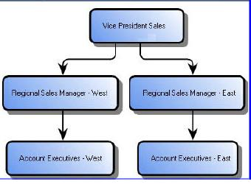

Commission for ***Account Executives – West*** will be rolled up to ***Regional Sales Manager – West.*** Similarly***,*** Commission for ***Account Executives – East*** will be rolled up to ***Regional Sales Manager – East.***

***Vice President Sales*** will get the commission roll up for ***Regional Sales Manager – West*** *and* ***Regional Sales Manager – East.***

### Held Commission

This generally refers to a type of commission which is being held for that particular month for an agent by an employer due to certain reasons.

* The most common scenario when a held commission can occur is an agent sells a policy and receives a commission. Now if the policy lapses due to non-payment of premium or surrendered, then the agency held the monthly commission in order to adjust the already paid commission amount to the agent.
* The held commission gets released in the next pay out or in any upcoming payout if the accounting team gets a release order.

### Persistency Rate

Persistency Rate refers to the percentage of policy contracts still in force at the specified time interval after they have been issued and shall be calculated on premium basis as well as policy basis. A higher rate is better than a lower rate. Early lapses and surrenders are not desirable for any of the stakeholders in the insurance sector. Persistency rates are used to place standards of performance for agents and some insurance companies also terminate agents with lower persistency rate. Agent’s appointment renewal may also depend on persistency rate. Failure to achieve a certain persistency rate may make an agent ineligible for renewal. Persistency rate can be used to pay commissions to salespeople also.

Salespeople can play a vital role to ensure high persistency (i) by avoiding soliciting unsuitable products (ii) by bringing in transparency in providing correct and complete details of suitable products to the prospective policyholders and (iii) by considering the needs of prospective policyholders.

### Deferred Commission

The component of initial commission, in case of regular premium and limited premium payment policies, paid in subsequent years subject to fulfillment of conditions specified by the insurer.

### Clubs and Awards

Insurance carriers recognize the success of its agents and present them with awards of distinction for their outstanding work and dedication. These awards may be in the form of membership to different clubs depending on success achieved by the agent. As an example an insurance company may have 3 types of club membership – President’s Club for the top 1percent agents, Championship Club for the top 3 percent agents and Toppers Club for the top 10 percent. Top producing agents are also rewarded with incentive conferences where the agent gets the chance to hear motivational speakers and network with colleagues at peer agencies. Insurance companies also support a number of industry achievements such as the National Sales Achievement Award (NSAA), National Quality Award (NQA), and Million Dollar Round Table (MDRT).

### Spiff

The term “SPIFF” means “Special Pay Incentives for Fast Sales” is a common approach for special sales achievement rewards.

* SPIFFs are most often aligned with short term business goals and target the achievement of any performer (or team of performers).
* Common practice is to pay out SPIFFs immediately upon achievement and in front of the sales team to spur on others to perform equally or better (sales people like to be challenged).
* SPIFFs can be material prizes (watches, TVs, etc.) or cash. If cash, great fun is to present the cash directly to the rep making as big a deal as you can while counting out a pile of small bills or a few big ones (keep security nearby for the fun of it).
* This activity turbo charge an agent to perform better.

### Circle of Excellence

This is a kind of award which an agent receives when he has an outstanding sales performance in an organization.

### Orphan policy

A policy is treated as an orphan policy if the agent, who procured that policy, is no longer working for the insurer who issued it or if his license is no longer valid.

### Management By objective

Management by objectives (MBO) is a process of defining objectives within an organization so that management and employees agree to the objectives and understand what they need to do in the organization in order to achieve them.

The term "management by objectives" was first popularized by Peter Drucker in his 1954 book 'The Practice of Management'.

The essence of MBO is

1. participative goal setting,
2. Choosing course of actions and decision making.

An important part of the MBO is the measurement and the comparison of the employee’s actual performance with the standards set. Ideally, when employees themselves have been involved with the goal setting and choosing the course of action to be followed by them, they are more likely to fulfill their responsibilities.

### Garnishment

A **garnishment** is a means of collecting a monetary judgment against a defendant by ordering a third party (the **garnishee**) to pay money, otherwise owed to the defendant, directly to the plaintiff. In the case of collecting for taxes, the law of a jurisdiction may allow for collection without a judgment or other court order.

**Wage Garnishment**

In United States this is the most common type of Garnishment. It is the process of deducting money from an employee's monetary compensation (including salary), sometimes as a result of a court order. Wage garnishments continue until the entire debt is paid or arrangements are made to pay off the debt. Garnishments can be taken for any type of debt but common examples of debt that result in garnishments include:

* child support
* defaulted student loans
* taxes
* unpaid court fines

When served on an employer, garnishments are taken as part of the payroll process. When processing payroll, sometimes there is not enough money in the employee's net pay to satisfy all of the garnishments.

For example, in a case with federal tax, local tax, and credit card garnishments, the first garnishment taken would be the federal tax garnishments, then the local tax garnishments, and finally, garnishments for the credit card. Employers receive a notice telling them to withhold a certain amount of their employee's wages for payment and cannot refuse to garnish wages. Employers must correctly calculate the amount to withhold, and must make the deductions until the garnishment expires.

### Debt

A **debt** is an obligation owed by one party (the debtor) to a second party, the creditor; usually this refers to assets granted by the creditor to the debtor, but the term can also be used metaphorically to cover moral obligations and other interactions not based on economic value.

A debt is created when a creditor agrees to lend a sum of assets to a debtor. Debt is usually granted with expected repayment; in modern society, in most cases, this includes repayment of the original sum, plus interest.

In finance, debt is a means of using anticipated future purchasing power in the present before it has actually been earned. Some companies and corporations use debt as a part of their overall corporate finance strategy.

A basic loan or "**term loan**" is the simplest form of debt. It consists of an agreement to lend a fixed amount of money, called the principal sum, for a fixed period of time, with this amount to be repaid by a certain date. An employer can give loans to its employees for various reasons like purchasing car (car loan).

# Chapter 4–ICM Implementation Case Study

# ICM Case Study

In order to effectively manage compensation, insurance organizations either use custom build software solutions or COTS (Commercial off the shelf) products. The trend in 2012 is that the insurance companies are moving towards COTS products and replacing their old Incentive Compensation Systems built on mainframe or excel based systems. The most popular COTS products available in the Incentive Compensation market space are

1. IBM Cognos Incentive Compensation Management (Formerly known as Varicent)
2. Callidus
3. Versata (also known as Trilogy)
4. Merced Incentive Compensation Management

In order to understand incentive compensation in a better way we are going to illustrate an incentive compensation system implementation case study. It will require a complete book to explain the complete case study in detail. Thus only some part of the overall solution will be explained here.

Note: There will be no questions in the CCP exam from this chapter. This chapter will help you to better understand some off the insurance incentive compensation concepts you have learned in the previous chapters.

## Case Study

ABC Incorporated is a leading life insurance company in US. ABC Incorporated is implementing the Varicent product suite as an on-premise Incentive Compensation Managment (ICM) solution to support their compensation process. This includes employee profile management, relationship (hierarchy) management and supporting integration and reporting.

The purpose of this project is to deliver the technology needed to support the new lines of business that ABC Incorporated is expecting to deploy. The system and its functionality will be an easy-to-maintain, end-to-end ICM solution based on the Varicent product suite.

The purpose of this project is to deliver the technology needed to support the new lines of business that ABC Incorporated is expecting to deploy.

### Expected Benefits

The startup of the new Agency channel and extension to the existing Financial Advisor(FA) channel have a wealth of requirements and intricate processes that will make the manual handling of commission payments and on-boarding of new agents/FA firms difficult.

As a result, the primary objective of the ICM project is to automate a majority of compensation calculations and processes, along with the management of agent and FA firm profiles. It is expected to provide the following key benefits:

* Provide the ability to manage complex hierarchies and commission policies
* Increase the flexibility of managing Incentive plans
* Reduce the time and effort to calculate commission payments for agents and FA firms
* Provide efficient and effective reporting to leverage the data captured and calculated within the ICM system
* Provide a simplified presentation mechanism to deliver commission reports
* Provide the capability and flexibility to grow the system as the business develops

### Functionalities in Scope

A summary of functionalities in scope is given in the below table -

| **AREA / CAPABILITY** | **DESCRIPTION** |
| --- | --- |
|
| Agent and FA Firm Profile Management | The system will manage on-boarding (new hires) and off-boarding (terminations) of Agents and FA Firms (entities). The system will keep a history of terminated entities but will allow for cease payments on commission payment and bonuses to these entities. New entities will be configured and added to the system for payment of their compensation components based on the business rules defined for their plan. Compensation meta-data related to each entity will be tracked within the Varicent model. |
| Hierarchy Management | The system will manage the business organizational hierarchy as it pertains to compensation. The hierarchy will determine reporting structure as well as access rights to view commission and bonus allocations for subordinates.  Business organizational hierarchy will be managed through the Varicent client. Compensation administrators and those granted access will be able to manipulate the hierarchy table as the hierarchy changes through the client UI. |
| Plan Management | 1. The system will allow for creation of new compensation plans as well as modifications to the existing compensation plan across both the Agency and Financial Adviser channels. Modification may involve changes to existing rate structures and/or creation of new compensation rules. |
| Data Integration (Inbound and Outbound) | The system will allow automated data integration via scheduled imports of data files (.txt, .csv) and Excel files.  The system will also provide data file (.txt, .csv) and excel outputs for integration with downstream outbound interfaces (ZBase). |
| Reporting | The system will provide complete query capabilities to all data stored and managed within the ICM solution.  The system will provide out-of-box ad-hoc reporting and analytic capabilities from the ICM solution.  Workflow will be setup to allow appropriate security access to reports. |

### Compensation Plan Overview

**ABC Incorporated** will be implementing the following compensation plans

| **PLAN ID** | **COMPENSATION PLAN** | **NUMBER OF PAYEES** | **ROLES** |
| --- | --- | --- | --- |
| PLAN 1.0 | Agency Compensation Plan | 1000 | Advisors, Senior Advisors, Executive Advisors, Unit Manager, Unit Director and Group Director |
| 1. PLAN 2.0 | Financial Advisor Compensation Plan | 1000 | Brokers. Brokerage Firm, and ABC Incorporated Internal Sales Manager |
| 1. PLAN 3.0 | Sales Incentive Scheme for Sales Manager | 500 | Sales Manager Managing the various Financial Advisor Accounts. |

### Plan Details – Agency Compensation Plan

* + **Eligibility**
    - All Advisers and Leaders, which includes Unit Managers, Unit Directors and Group Directors.
  + **Employee Breakdown by Region/Business**

**Group Director**

**Unit Director**

**Unit Manager**

**ABC Inc. Agency Structure - 3 Tiers**

**Advisers**

**Advisers**

**Advisers**

* + **Leave of Absence (LOA)**
    - Commission will not be paid when the Sales Agent has been Suspended or Terminated. When the Sales Agent is on Marriage Leave, Maternity Leave, Sick Leave, Study Leave, Compassionate leave he will be eligible for Commission. For any other reasons Commission will not be paid. Payment of commission will take place only upon approval from the managing authority, I.e. Chief Agency Officer
  + **Guarantee**
    - Similar components exist; they are the Financing Scheme and the Transition Program. The Financing scheme is based on recommendation and approval from the management and it is only eligible for New Hires. However, the Transition Program is only for experience hires.
  + **New Hire**
    - New hire are eligible for commission the very moment they start making business for the company. However, they are also eligible for the Financing Scheme which is totally base on their manager’s recommendation
  + **Adjustments**
    - Adjustments if any will be clawed back. Adjustments can be because of a Training Subsidy, Policy Cancellation etc. This negative adjustment can cause Negative Payout. In case of Negative payout the amount will be carry forward to the next period. Adjustments are applied before the negative balance calculations
  + **Transfers**
    - Initiated only by the Company. It will not be initiated by the Agent or Leaders (Unit Manager/Unit Director/ Group Director) request
    - All the components related to the Agents are compared against his record effective date.
    - The Agent Hierarchy will be effective dated and will be design to be able to correctly calculate commission for promotions, transfers (for when an up-line manager leaves) and resignations.
    - A payee can be eligible for multiple plans during a given Incentive Period
  + **Proration**
    - Not applicable
  + **Reporting Hierarchy**
    - Span of Control – Each leader cannot have more than 15 agents. In case a Unit Manager leaves the organization, the people under him are first assign to the Group Director. The Group Director can have a maximum of 15 agents and if he cannot accommodate the rest of the advisor because of the Span of Control rule, the Advisors would have the choice to select their own Unit Manager or even move to another Unit. The unit must be within the GD’s umbrella. Only when no unit with the GD’s umbrella can accommodate the orphaned agents, then these agents can choose to join units outside the GD’s umbrella.
    - Note: The system will have the facility to allow changes to the Span of Control requirements in the future.

In the event MAS reduces the 1:15 ratio, then the system will be flexible enough to change accordingly.

**Group Director**

**Unit Director**

**Unit Manager**

**ABC Corp Agency Structure - 3 Tiers**

**Advisers**

**Advisers**

**Advisers**

* + **Periodicity of Plan / Plan Calendar**
    - Bi Monthly for all Regular Commissions - First Year Commission ,Renewal Year Commission and Overrides Commission
  + **Negative Balances / Adjustments / Clawback**
    - Negative balances are carried over to the next period and offset against the commission earned for that month. This carry forward will continue until a positive balance is achieved.
    - Adjustments to the First Year Commission would affect First Year Commission, Production bonus (if the tier is affected), and any other bonus dependant on the First Year Commission component.
    - Cancellations, Training subsidy, other adjustments may cause negative balances
    - If an advisor, on a financing scheme, leaves the company, any monies that have been paid to him in advance will be clawed back as follows:
      * 20% from his leader
      * 20% from the company
      * 60% from the advisor.
  + **Payroll Processing**
    - The cutoff for all payroll processing is the 15th and the last day of the month
    - Note: The First Period is 1st to the 15th of the Month and the second period is the 16th to the last day of the month.
    - Twice a month - 24th and the 9th of the month
    - Payment to be made on the 24nd of the Month for First Year Commission, Renewal Yearly Commission and Override Commission
    - Payment to be made on the 9th of the Month for all payments including First Year Commission , Renewal Yearly Commission and Overrides Commission..
    - Claw backs, and any other form of Manual Adjustments. - Can take place on either 9th or 24th depending on which period the transaction is effected
    - Monthly Fixed Financing Payments (New Agent) - Can be paid either on 9th or 24th depending on the appointment date of the new recruit – if appointed within 1st to 15th of the month, payment occurs on 24th of the same month, if appointed within 16th to last day of the month, payment occurs on 9th of new month
    - Monthly Transition Allowance Payments (Industry Hires) - Can be paid either on 9th or 24th depending on the appointment date of the new recruit – if appointed within 1st to 15th of the month, payment occurs on 24th of the same month, if appointed within 16th to last day of the month, payment occurs on 9th of new month
  + **Currency**
    - USD – US Dollars

### Plan Details – Financial Advisor Compensation Plan

* + **Eligibility**
    - All Financial Advisor Brokerage Firm and Brokers who have signed a contract with ABC Incorporated.
  + **Employee Breakdown by Region/Business** 
    - All Brokers and Brokerage firm reports to ABC Incorporated Sales Manager.
  + **Leave of Absence (LOA)**
    - For all Brokers registered with Brokerage Firm Commission will be paid to the Brokerage Firm directly.
  + **Guarantee**
    - None
  + **New Hires**
    - None of the Financial Advisor is an Employee of ABC Incorporated. They are basically employed by their agencies.
  + **Adjustments**
    - Any changes to the Annual Premium Equivalent on the Regular Premium Plan, Term Plan and Single Premium Plan would affect the Commission and the Commission would be adjusted accordingly. These changes would also impact the Persistency Bonus and Retro Pot component.
  + **Transfers**
    - None of the Financial Advisor is an Employee of ABC Incorporated. They are basically employed by their agencies.
    - However, in the case when An Advisor Moves to another Agency the trail commission will follow him to the new Firm. The Effective date will be configured in the system for proper calculations of trail commission.
  + **Proration**
    - Any changes to the Annual Premium Equivalent on the Regular Premium Plan, Term Plan and Single Premium Plan would affect the Commission and the Commission would be adjusted and prorated accordingly. These changes would also impact the Persistency Bonus and Retro Pot component. Also, in the case when a contract is terminated with an agent, the amount of commission that has been already paid would be claw back. These claw-backs would be prorated. As an example, let us say a person leaves after a year, the Regular Premium commission that was paid to him (calculated as 3% * Term * APE) for an 18 month period, will be clawed back. If the lump sum total commission paid was S$12,000 for 18 months, and the FA leaves after a year, the claw back would be pro-rated to deduct what has been already paid, in this case, 1/3* S$12,000.
  + **Reporting Hierarchy**
    - All Financial Advisor and Financial Advisor Firm report to ABC Incorporated Financials Sales Manager.
  + **Periodicity of Plan / Plan Calendar**
    - Retro Pot and Persistency Bonus are paid yearly and any other components are paid as and when businesses are made.
  + **Negative Balances / Adjustments / Clawback**
    - Negative balances are carried over to the next period and offset against the commission earned for that month. This carry forward will continue until a positive balance is achieved.
  + **Payroll Processing**
    - Retro Pot and Persistency Bonus are paid yearly and any other components are paid as and when businesses are made. The payment frequency is different for each of the Financial Advisor firm.
  + **Currency**
    - Support Multiple Currencies.

### Plan Details – Retails Sales Incentive Scheme

* + **Eligibility**
    - Eligible only to those who are able to highly influence sales results, close to the actual transaction and, wherever possible, have direct and sole responsibility for these over any given distributor /corporate schemes.
    - Must be in Full Time Employment at the time the bonus payment is made
    - Achieve performance score of at least 2 in each quarter in any given year and must not be subject to a formal disciplinary warning at the time a bonus payment is due
  + **Employee Breakdown by Region/Business** 
    - All Eligible Sales Managers.

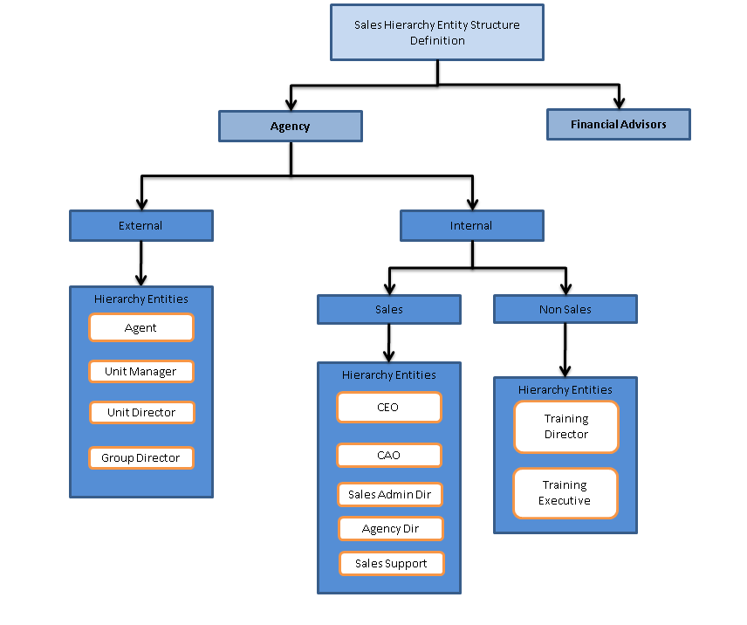

* + **Leave of Absence (LOA)**
    - Leave will be based on management approval. However during the leave period the Agent cannot submit any cases. The leave information will be sent to ZBase to track the policy sales by the respective agent.
  + **Guarantee**
    - None
  + **New Hires**
    - None
  + **Adjustments**
    - None
  + **Transfers**
    - None
  + **Proration**
    - New Members or Re-Qualifiers will receive a pro-rate bonus payment if they become an eligible Scheme Member during the year based on completed whole month’s service as an eligible Scheme Member.
    - Part-Time Scheme Members will receive a target and bonus payment directly proportional to their Full Time Equivalent (FTE) percentage. E.g. a scheme member working 20 hours per week would be 57% FTE and would receive a proportional target and bonus payment e.g. 57% of the bonus payment due.
    - Leavers to the Scheme will receive any bonus payment due the month after leaving the scheme based on issued business only at the point of their leaving or transfer. Pipeline business not issued prior to leaving the scheme will not be included. Any payment due will be calculated using whole month’s service as an eligible scheme member.
  + **Reporting Hierarchy**
    - All Sales Manager are assigned accounts which consist of Financial Advisors and Financial Advisor Firms.
  + **Periodicity of Plan / Plan Calendar**
    - Quarterly
  + **Negative Balances / Adjustments / Claw back**
    - Payments may be withheld, reduced or clawed back where the business submitted subsequently result in a loss to the ABC Incorporated Group.
  + **Payroll Processing**
    - Payments will be calculated at the end of each calendar quarter and will be converted from Sterling to Local Currencies at the SAP average rate for the Calendar Quarter and paid the following Month.
  + **Currency**
    - Support Multiple Currencies.

### Agency Component Requirements

| **ID** | **COMPONENT** | **REQUIREMENT** | **Frequency** | **RATIONALE** |
| --- | --- | --- | --- | --- |
| COMP 1.0 | First Year Commission | The First Year Commission is the Base Commission which is calculated as a percentage of the Premium. The payout percentage is applied against the Premium. The First Year Commission is calculated in ZBase and will be brought over to Varicent via an Interface Process. | Bi Monthly | The First Year Commission component will be the base commission where most of the Agents plan components are calculated from. It is eligible for all Advisors and their Leaders on the Agency Channel. |
| COMP 2.0 | Renewal Commission | The Renewal Commission is the Commission which is calculated as a percentage of the Trail or Renewal Premiums that are being paid by the customer on a policy. The payout percentage is applied against the Premium Paid. The Renewal Commission is calculated in ZBase and will be brought over to Varicent via an Interface Process. | Bi Monthly | The Renewal Commission component will be the base commission for all ongoing business. Renewal Bonus, Persistency Bonus are base out of the Renewal Commission. It is eligible for all the Advisors and their Leaders on the Agency Channel. |
| COMP 3.0 | Override Commission | Overrides are paid to leaders on their subordinate's First Year Commission and Renewal Commission. This is to reward the leader for his unit's sales. | Bi-Monthly | Override Commission is being paid to the Leaders- . Unit Manager, Unit Director and Group Director - of each of the Unit as a percentage of their team First Year Commission and Renewal Commission |
| COMP 4.0 | Production Bonus | Production bonus is computed as a percentage of First Year Commission and a 24 month rolling average for persistency modifier. It is paid quarterly. | Quarterly | Available to all levels who have personal production and earning First Year Commission.  The production bonus is based on weighted earned FYC achieved in the calendar year  For protection business, the FYC used in calculation is 120% of actual earned First Year Commission.  . |
| COMP 5.0 | Renewal Bonus | Renewal bonus is computed on RYC and paid Half Yearly.  Renewal Bonus will not be used for overrides commission. | Quarterly | Renewal bonus is computed on RYC and paid Half Yearly.  To be paid for the 2nd and 3rdyear  Different rates for different product types, and for riders.  Filtered for internal products only  The Renewal bonus is based on renewal regular premiums collected in the respective calendar year.  The bonus scale can be changed at company’s discretion |
| COMP 6.0 | Persistency Bonus on RYC  (24 month rolling) | Payable only on regular premium policies still in-forced after 24 months , as a % of all RYC (2nd and 3rd year commission) payable  Persistency measure is the 25th month persistency which lapses include  lapsed policies  premium holiday  paid-up policies  reduced annual premium  surrendered policy with duration month less than or equal to 24 months | Quarterly | Reward Advisers for their business quality since it increases the company profitability if fewer policies lapse.  Payable only on regular premium policies still in-forced after 24 months , as a % of RYC |
| COMP 7.0 | Loyalty Bonus | It is a deferred Commission, paid based on Rank and Tier, starting from employee's fourth year of service.  Paid to encourage employee retention | Vested on 5th year as a % of FYC or Override (Yearly) | Deferred commission payable based on rank and tier. This also Increase the total overrides for managers.  An Adviser or Leader needs to fulfill both conditions of years of service (16 and more) and be at least age 55 years or older before he is entitled to 100% of the vesting scale |
| COMP 8.0 | Practice Expansion Incentive | The Practice Expansion Incentive is being incorporated to avoid frequent spin-offs at Tier 2, thus reducing costs. It address the loss of vested interest and overrides for Tier 2 UDs and Incentivize the UD to manage and mentor his future UM and advisers  Encourages recruitment and development of high productivity advisers and it will be paid for 5 years.  Percentage of the new Unit Manager team FYC and RYC | When a Senior Executive or Executive is promoted to Unit Manager under Unit Director or Unit Manager  (Yearly) | The Practice Expansion Incentive is being incorporated to avoid frequent spin-offs at Tier 2  Address the loss of vested interest and overrides for the Senior Tier 2 manager with incentives to continue mentoring his newly promoted manager  Payable to the Tier 2 UD for the first UM from his direct unit  The PEI replaces the loss of overrides for the UD. The PEI is structured to drive recruitment and productivity as incentives are paid on the number of agents in each FYC band x % of FYC x Payout Amt. Payout will be in Jan after each financial year and the  Payment of PEI stops under any one of the three circumstances:  PEI payment runs out in 5 years (refer to PEI schedule of payment rates) if no one else is promoted  When another SA/EA is promoted to UM within the 5-year PEI payment period and that triggers a spin-off.  When an agent under the newly promoted UM is also promoted to the rank of UM |
| COMP 9.0 | Spin Off | Address the loss of overrides for a GD when his UD breaks away to form a new Tier 3 family  Recognize the GD’s past efforts in developing managers and their agents | When a Unit Director gets promoted to Group Director  (Yearly) | Payable to the current Tier 3 GD when his Tier 2 UD gets promoted to a GD and breaks away to form his own Group.  The current GD will lose the indirect override on his newly promoted GD and his Group which in turn be compensated by a spin off bonus which is a percentage of the latter’s personal income for the next five years. The percentage rate will be defined on the Spin Off rate table.  The personal income of the newly promoted GD includes commissions and bonuses from his personal production as well as his direct and indirect overrides on his UM’s.  Address the loss of overrides for the GD when his down line UD breaks away from his family tree to form his own and to recognize his past efforts |
| COMP 10.0 | Financing Scheme | Financing Scheme for New hires, where commission is advanced to them.  There are 2 versions of the Scheme – SGD 3000 and SGD 5000. The S$3000 is paid across 12 months and the S$5000 is paid across a 6 months period. During this period all commission from new policy sales or ongoing renewal commission that the Agent has made is hold back and release only after the 12 months/6 months period. |  | A fixed payment to new recruit for the 1st 3 months of service and on condition of meeting FYC requirements will continue to receive the next 3 months of payment. The new recruits are validated every 3 months for FYC achieved and upon meeting the requirements, will receive fixed payments for up to 6 or12 months maximum depending on the scheme chosen.  During this period all commission from new policy sales or ongoing renewal commission that the Agent has made is hold back and release only after the 12 months/6 months period. This scheme is eligible only for new hires. |
| COMP 11.0 | Transition Program | This program is eligible for Industry Hires who are being recruited from competitors. The program key metrics is the Advisor Past Annual Income |  | This program is eligible for Industry Hires who are being recruited from competitors. The program key metrics is the Advisor Past Annual Income. 40% of the Transition Bonus is paid up front once the Advisor moves into ABC Incorporated. The remaining 60 % is spread across 8 quarters. The agent will also have an APE target to achieve which dictates the future payment. The Target APE is calculated by looking at his Past Annual production * APE Target Factor.  Note: The above rates are subject to change and will be documented on the design document. |

### Reporting Requirements

Some of the reporting requirements are given below -

| **ID** | **REPORT** | **DESCRIPTION** | **AUDIENCE** | **CHANNEL** | **FREQUENCY** |
| --- | --- | --- | --- | --- | --- |
| 1 | Commission Statement for Agents/Leaders | Commission Statement to display all payments and deductions, with option to drill down into the individual sub-reports below | Agents: View their own reports Leaders: View their own reports, and their Direct and Indirect Units Corporate Managers: View all Reports | Agency | BiMonthly - on the 18th and 3rd of the month |
| 2 | Compensation Plan Report. Section: Production and FYC Report | Annual Premium Equivalent(APE), no of Cases incepted and FYC per Date. Further drill down to individual policies and transactions The yearly consolidated report will contain data for the entire year. | Agents: View their own reports Leaders: View their own reports, and their Direct and Indirect Units' reports Corporate Managers: View all Reports | Agency | BiMonthly - on the 18th and 3rd of the month |
| 3 | Compensation Plan Report. Section: Renewal and RYC Report | APE, no of renewals and RYC per Date. Further drill down to individual policies and transactions | Agents: View their own reports Leaders: View their own reports, and their Direct and Indirect Units' reports Corporate Managers: View all Reports | Agency | BiMonthly - on the 18th and 3rd of the month |
| 4 | Compensation Plan Report. Section: Production Bonus Report | Production Bonus Calculations - with FYC used, Tier information, Rate applied, persistency modifier and final payout | Agents: View their own reports Leaders: View their own reports, and their Direct and Indirect Units' reports Corporate Managers: View all Reports | Agency | Data is refreshed Quarterly - on the 3rd day of the second month of the quarter |
| 5 | Compensation Plan Report. Section: Renewal Bonus Report | Renewal Bonus Calculations - with RYC Used, Tier information, Rate applied, persistency modifier and final payout | Agents: View their own reports Leaders: View their own reports, and their Direct and Indirect Units' reports Corporate Managers: View all Reports | Agency | Data is refreshed Quarterly - on the 3rd day of the second month of the quarter |
| 6 | Compensation Plan Report. Section: OverRides Report | FYC and RYC broken down by agents in Direct/indirect units, and their % contribution to the overrides | Leaders: View their own reports Corporate Managers: View all Reports | Agency | BiMonthly - on the 18th and 3rd of the month |
| 7 | Targets vs Actual | Year to Date tracking of actuals vs targets (for APE, Activity) | Agents: View their own reports Leaders: View their own reports, and their Direct Units reports Corporate Managers: View all Reports | Agency | Monthly |
| 8 | Lapses Report | List of policies lapsed as of a specific date. Lapsed policies accumulate in this report, along with their outstanding premium. | Agents: View their own reports Leaders: View their own reports, and their Direct and Indirect Units Corporate Managers: View all Reports | Agency | Daily |
| 9 | Commission Statement for FAs | Commission Statement for FAs, with sections on:  a. Commission and overrides at a policy level - including individual FA Name b. Retro Pot Bonus c. Persistency Bonus | Matt Internal Sales Managers Internal Operations Team External FAs Admin Team (Not via Web) | FA | Depends on Brokerage (weekly, monthly, bimonthly) |
| 10 | Commission Statement for Internal Sales Managers | Fields for Achievement, Target, Achievement %, Tier, Rate applied | Matt (view All Sales Managers' Reports) Internal Sales Managers (View Own Report) | FA | Quarterly |
| 11 | Sales against Target (Sales Credit) | Monthly Actual, YTD actual, Prev YTD actual, % growth, per broker | Matt Internal Sales Managers Internal Operations Team | FA | Monthly |
| 12 | Sales By Month (APE) | APE per month broken down by Broker | Matt Internal Sales Managers Internal Operations Team | FA | Monthly |

### Data Model for ICM implementation of ABC Incorporated

### Personal Data Tables

Following are the personal data tables.

1. Payee - Default hierarchy table, used to store agent's and agency's information.
2. cfgOrganization - Custom table, used to store agency's information
3. cfgPerson - Custom table, used to store agent's information
4. cfgPayeeHierarchy - Custom table, used to store the hierarchy of the Agents and Agencies
5. cfgEffectivePayee – Custom table, used to store payee effective date information
6. cfgEmployment - Custom table, used to store the employment details for an agents
7. cfgPayeeAddress - Custom table, used to store Agent's and Agency's address information
8. cfgPayeeBank - Custom table, used to store Agent's and Agency's bank's information
9. cfgPayeeTraining – Custom table, used to store payee training information
10. cfgPayeeEducation – Custom table, used to store payee education information
11. cfgPayeeEmail – Custom table, used to store payee email information
12. cfgPayeeExam – Custom table, used to store payee examination completed information
13. cfgPayeeExtension – Custom table, used to store additional payee info
14. cfgPayeePhone – Custom table, used to store payee phone details
15. cfgPayeeActivity – Custom table, used to store payee activities



### Personal Contract Data Tables

Following are the payee contract data tables.

1. cfgPayeeLicense – Custom table, used to store license information
2. cfgPayeeRegistration - Custom table, used to store the registration information with insurance regulatory body
3. cfgProducerAgreement - Custom table, used to store producer agreement information
4. cfgDistributor Agreement – Custom table, used to store distributor agreement
5. cfgCarrierAppointment – Custom table, used to store carrier appointment information



### Varicent Production and Commission Data Tables

Following are the production and commission data tables.

1. Commission Data – Data table, used to store commission data
2. Production Data – Data table, used to store production data

**Commission Data Table**

| **Field Name** | **Varicent Data Type** | **Pick List**  **(Foreign Key)** | **Description** | **Primary Key** |
| --- | --- | --- | --- | --- |
| RecordID | Text |  | RecordDate | Y |
| BankNumber | Text |  | BankNumber |  |
| BranchNumber | Text |  | BranchNumber |  |
| ServicingAgentNumber | Text | Payee | ServicingAgentNumber |  |
| CommissionAgentNumber | Text | Payee | CommissionAgentNumber |  |
| ReferralAgentNumber | Text | Payee | ReferralAgentNumber |  |
| ExternalReference1 | Text |  | External reference for Bank Agent |  |
| ExternalReference2 | Text |  | External reference for Branch Agent |  |
| ExternalReference3 | Text |  | External reference for Servicing Agent |  |
| ExternalReference4 | Text |  | External reference for Commission Agent |  |
| ExternalReference5 | Text |  | External reference for Referal Agent |  |
| ClientName1 | Text |  | Bank Name (Banca) |  |
| ClientName2 | Text |  | Branch Name (Banca) |  |
| ClientName3 | Text |  | Servicing Agent name. Concatenation of Surname and Given Name |  |
| Client Name 4 | Text |  | Commission agent name. Concatenation of Surname and Given Name |  |
| Client Name 5 | Text |  | Referral agent name. |  |
| ContractNumber | Text |  | ContractNumber |  |
| LifeNumber | Text |  | ZLiFE Life Number e.g. ‘01’ |  |
| CoverageNumber | Text |  | LiFE Coverage Number e.g. ‘01’ |  |
| RiderNumber | Text |  | ZliFE Rider Number e.g. ’00’ |  |
| ContractType | Text | valContractTypeCode | ProductType |  |
| PremiumType | Text | valPremiumTypeCode | PremiumType |  |
| ComponentCode | Text | valComponentCode | This is a 4 characters code representing the coverage and riders.  e.g.  SUWA – ZLS RP ILP Protection Coverage  SUWB – ZLS RP ILP Savings Coverage  SUW1 – ZLS SP ILP  SNUA – ZLS Term Coverage  SNDA – ZLS Disability Rider  SNDB – ZLS Disablity Rider (UDR)  SNRC – ZLS Spouse Rider  SNRD – ZLS Spouse Rider (UDR)  Etc. |  |
| RiskCommencementDate | Date |  | RiskCommencementDate |  |
| IssueDate | Date |  | IssueDate |  |
| CoolingOffDate | Date |  | CoolingOffDate |  |
| EffectiveDate | Date |  | EffectiveDate |  |
| PaidToDate | Date |  | Instalment to date.  Eg. If we have a monthly premium with due date on 2011/01/25, then the instalment to date is 2011/02/25 |  |
| TransactionNumber | Text |  | TransactionNumber |  |
| BillingFrequency | Text |  | Billing/payment frequency.  i.e.  01 – Yearly  02 – Half Yearly  04 – Quarterly  12 – Monthly  00 – Single Premium |  |
| ExchangeRate | Numeric |  | ExchangeRate |  |
| ContractCurrency | Text | Currency | ContractCurrency |  |
| CoverPremContractCurr | Numeric |  | CoverPremContractCurr |  |
| CoverCommContractCurr | Numeric |  | CoverCommContractCurr |  |
| AgentPaymentCurrency | Numeric |  | AgentPaymentCurrency |  |
| CoverCommAgtPayCurr | Numeric |  | CoverCommAgtPayCurr |  |
| PolicyYear | Text |  | Number of years from coverage/rider risk commencement date up to instalment date. |  |
| TypeofCommission | Text | valCommissionTypeCode | Type of commission  i.e.  S- Single Premium  I – Initial commission,  R – Renewal commission  T – Top Up Commission |  |
| TransactionCode | Text | valTransactionTypeCode | This is 4 character code representing the transaction that calculated the commission  i.e.  T642 – Contract Issue  B522 – Premium Collection  T679 - Single Premium Top up  T607 - Alter from Inception  T646 – Cancel from Inception  TR7K- Freelook Cancellation  T656- Full Contract Reversal  T557-Component Add  T536- Paid to Date Advance  T591 – Recurring Single Premium Apply |  |
| TransactionDescription | Text |  | TransactionDescription |  |
| RiskAge | Numeric |  | RiskAge |  |
| RiskTerm | Numeric |  | RiskTerm |  |
| PremiumAge | Numeric |  | PremiumAge |  |
| PremiumTerm | Numeric |  | PremiumTerm |  |
| ContractOwnerName | Text |  | ContractOwnerName |  |
| LifeInsuredName | Text |  | LifeInsuredName |  |
| SinglePrmContractCurr | Text |  | SinglePrmContractCurr |  |
| SinglePrmLocalCurr | Text | Currency | SinglePrmLocalCurr |  |
| SerialNumber | Numeric |  | Serial Number |  |
| LayeringNumber | Numeric |  | Layering Number |  |
| OffshoreIndicator | Text |  | This is a 1 character code indicating whether the policy is onshore or offshore (required by finance)  i.e.  O – Off shore  S – On shore |  |
| ParticipatingNonParticipating | Text |  | This is a 1 character code indicating the fund type of the commission (required by finance)  i.e.  P – Participating  N – Non participating  U – Investment/Unit linked |  |

Production Data Table

| **Field Name** | **Varicent Data Type** | **Pick List**  **(Foreign Key)** | **Description** | **Primary Key** |
| --- | --- | --- | --- | --- |
| RecordDate | Text |  | RecordDate | Y |
| BankNumber | Text |  | BankNumber |  |
| BranchNumber | Text |  | BranchNumber |  |
| ServicingAgentNumber | Text |  | ServicingAgentNumber |  |
| CommissionAgentNumber | Text |  | CommissionAgentNumber |  |
| ReferralAgentNumber | Text |  | ReferralAgentNumber |  |
| ContractNumber | Text |  | ContractNumber |  |
| LifeNumber | Text |  | LifeNumber |  |
| CoverageNumber | Text |  | CoverageNumber |  |
| RiderNumber | Text |  | RiderNumber |  |
| ContractType | Text | valContractTypeCode | This is a 3 characters code representing the main product. Eg.  SIA – ZLS RP ILP (Protection)  SIB – ZLS RP ILP (Savings)  SIC – ZLS SP ILP  STA – ZLS Zterm Plan  Etc. |  |
| ComponentCode | Text | valComponentTypeCode | This is a 4 characters code representing the coverage and riders.  e.g.  SUWA – ZLS RP ILP Protection Coverage  SUWB – ZLS RP ILP Savings Coverage  SUW1 – ZLS SP ILP  SNUA – ZLS Term Coverage  SNDA – ZLS Disability Rider  SNDB – ZLS Disablity Rider (UDR)  SNRC – ZLS Spouse Rider  SNRD – ZLS Spouse Rider (UDR)  Etc. |  |
| RiskCommencementDate | Date |  | Coverage/Rider risk commencement date. |  |
| IssueDate | Date |  | IssueDate |  |
| BillToDate | Date |  | Contract billed to date at the time of contract change |  |
| EffectiveDate | Date |  | EffectiveDate |  |
| PaidToDate | Date |  | Contract paid to date at the time of contract change |  |
| TransactionNumber | Text |  | TransactionNumber |  |
| SerialNumber | Text |  | SerialNumber |  |
| BillingFrequency | Text |  | BillingFrequency |  |
| ExchangeRate | Text |  | ExchangeRate |  |
| ContractCurrency | Text |  | ContractCurrency |  |
| CoverPremContractCurr | Text |  | CoverPremContractCurr |  |
| CoverageLocalCurrency | Text |  | CoverageLocalCurrency |  |
| CoverPremLocalCurr | Text |  | CoverPremLocalCurr |  |
| PolicyYear | Text |  | Number of years from coverage/rider risk commencement date up to data extract date |  |
| Annual premium | Numeric |  | Annual instalment premium amount |  |
| Initial commission |  |  | Total Initial Commission amount |  |
| Installment Premium | Numeric |  | Installment premium amount (at component level) |  |
| Customer | Text |  | Customer |  |
| RiskAge | Text |  | Age of the Life Insured at risk cessation date. e.g. 60, 100. |  |
| RiskTerm | Text |  | Component Risk Term e.g. 10, 15, 20, 55 |  |
| PremiumAge | Text |  | Age of the Life Insured at premium cessation date. e.g. 60, 100. |  |
| PremiumTerm | Numeric |  | Component premium term e.g. 10,15, 55 |  |
| ContractOwnerName | Text |  | ContractOwnerName |  |
| LifeInsuredName | Text |  | LifeInsuredName |  |
| TransactionCode | Text |  | TransactionCode |  |
| TransactionDescription | Text |  | TransactionDescription |  |
| SinglePrmContractCurr | Numeric |  | SinglePrmContractCurr |  |
| SinglePrmLocalCurr | Numeric |  | SinglePrmLocalCurr |  |
| Onshore/Offshore Indicator | Text |  | This is a 1 character code indicating whether the policy is onshore or offshore (required by finance)  i.e.  O – Off shore  S – On shore |  |
| ParNonParUL | Text |  | This is a 1 character code indicating the fund type of the commission (required by finance)  i.e.  P – Participating  N – Non participating  U – Investment/Unit linked |  |
| ContractStatus | Text | valContractStatusCode | This is a 2 character code that identifies if the risk status of the contract.  (refer to table T3623 for the complete list)  i.e.  CF - Cancelled from Inception  DC- Contract Declined  DH - Approved Death Claim  EX - Expiry  IF - In Force  LA - Contract Lapsed  MA - Contract Matured  NT - Not taken Up  PO - Contract Postponed  PS - Contract Proposal  PU - Paid Up Contract  RD - Registered Death Claim  SU - Contract Surrendered  TR - Contract Terminated  UW - Underwriting  VR - Vesting Registered  WD - Contract Withdrawn |  |
| ContractPremiumStatus | Text | valPremiumStatusCode | This is a 2 character code that identifies if the premium status of the contract.  (refer to table T3588 for the complete list)  i.e.  AP Annuity in Payment  CF Cancelled from Inception  DC Declined  DH Deceased  ET Extended Term Insurance  EX Expired  FP Fully Paid  HA Premium Holiday  HP PH Reinstatement Pending  LA Lapsed  MA Matured  NF Non-Forfeiture Surrendered  NT Not taken Up  PO Contract Postponed  PP Premium Paying  PS Proposal  PU Made Paid-up  SP Single Premium  SU Fully Surrendered  VR Vesting Registered  WD Withdrawn |  |
| CoverageStatus | Text | valCoverageStatusCode | This is a 2 character code that identifies if the premium status of the coverage or rider.  (refer to table T5682 for the complete list)  i.e.  CF Cancelled From Inception  DC Declined  EX Expiry  IF In Force  LA Lapsed  MA Matured  NT Not taken Up  PU Paid Up  PS Proposal  HP PH Reinstatement Pending  RT Reducing Term  RD Registered Death  SU Surrender  CR Vesting Registered  WD Withdrawn |  |
| CoveragePremiumStatus | Text | valCoveragePremiumStatusCode | This is a 2 character code that identifies if the premium status of the coverage or rider.  (refer to table T5681 for the complete list)  i.e.  AP Annuity in Payment  CF Cancelled from Inception  DC Declined  EX Expiry  ET Extended Term Insurance  FP Fully Paid  LA Lapsed  MA Matured  NT Not taken up  PU Paid Up  PH Premium Holiday  PP Premium Paying  PR Proposal  HP PH Reinstatement Pending  RT Reducing Term  SP Single Premium  SU Surrender  CR Vesting Registered  WV Waiver of Premium  WD Withdrawn |  |

### Payments and Adjustments Tables

1. cfgManualPayment – Custom table, used to store the manual payments
2. cfgManualPayments Attributes – Custom table, used to store the types of manual payments

**cfgManualPayments**

| **Field Name** | **Varicent Data Type** | **Pick List**  **(Foreign Key)** | **Description** | **Primary Key** |
| --- | --- | --- | --- | --- |
| PayeeID | Text | Payee | Payee ID | Y |
| ComponentType | Text | valCommissionType | Component Type | Y |
| AdjustmentFor | Date |  | Adjustment For |  |
| AdjustmentPaid | Date |  | Adjustment Paid |  |
| AdjustmentDate | Date |  | Adjustment Date |  |
| AdjustmentAmount | Numeric |  | Adjustment Amount |  |
| ApprovalStatus | Text |  | Approval Status |  |
| Comments | Comments |  | Comments |  |
| AdjustmentID | Text |  | Adjustment ID | Y |

**cfgManualPaymentsAttributes**

| **Field Name** | **Varicent Data Type** | **Pick List**  **(Foreign Key)** | **Description** | **Primary Key** |
| --- | --- | --- | --- | --- |
| Paye ID | Text | Payee | Payee ID | Y |
| Component Type | Text | valCommissionType | Component Type | Y |
| ComponentStartDate | Date |  | Component Start Date | Y |
| ComponentEndDate | Date |  |  |  |
| ComponentStopDate | Date |  |  |  |

**Rate Tables**

Rate tables are custom tables used to store the rates for the different compensation component.

1. cfgOverrideRates
2. cfgProductFactor
3. cfgProductionBonusRate
4. cfgRetroPotBonusRate
5. cfgBonusModerator
6. cfgPersistencyBonus
7. cfgPayeeCommPlans
8. cfgLoyaltyBonus
9. cfgPEIPayoutRate
10. cfgSpinOffRateTable
11. cfgTransactionTypeCodeTable

**cfgOverrideRates**

| **Field Name** | **Varicent Data Type** | **Pick List**  **(Foreign Key)** | **Description** | **Primary Key** |
| --- | --- | --- | --- | --- |
| StartDate | Date |  | StartDate | Y |
| EndDate | Date |  | End Date |  |
| LevelFrom | Text | Title Table | Level From (Eg. Adviser) | Y |
| LevelTo | Text | Title Table | Level To (Eg. Group Director) | Y |
| IDOR | Text |  | IDOR |  |
| PercentageRate | Numeric |  | Percentage Rate |  |
| Channel | Text |  | Channel | Y |

**cfgProductFactor**

| **Field Name** | **Varicent Data Type** | **Pick List**  **(Foreign Key)** | **Description** | **Primary Key** |
| --- | --- | --- | --- | --- |
| StartDate | Date |  | StartDate | Y |
| EndDate | Date |  | End Date |  |
| ProductType | Text | Product Table | Product Type | Y |
| Multiplier Factor | Numeric |  | Multiplier Factor |  |
| Channel | Text |  | Channel | Y |

**cfgProductionBonusRate**

| **Field Name** | **Varicent Data Type** | **Pick List**  **(Foreign Key)** | **Description** | **Primary Key** |
| --- | --- | --- | --- | --- |
| StartDate | Date |  | StartDate | Y |
| EndDate | Date |  | End Date |  |
| TierBand | Text |  | Tier Band | Y |
| MultiplierFactor | Numeric |  | Multiplier Factor |  |
| BonusType | Text |  | Bonus Type (Production, Renewal Bonus etc.) | Y |
| Year | Numeric |  | Year – the year in which the rate is to be paid out |  |
| Channel | Text |  | Channel | Y |

**cfgRetroPotBonusRate**

| **Field Name** | **Varicent Data Type** | **Pick List**  **(Foreign Key)** | **Description** | **Primary Key** |
| --- | --- | --- | --- | --- |
| StartDate | Date |  | StartDate | Y |
| EndDate | Date |  | End Date |  |
| Persistency | Text |  | Tier Band | Y |
| APE | Numeric |  | Multiplier Factor | Y |
| Rate | Text |  | Bonus Type (Production, Renewal Bonus etc.) |  |
| Year | Numeric |  | Year – the year in which the rate is to be paid out | Y |
| Channel | Text |  | Channel | Y |

**cfgBonusModerator**

| **Field Name** | **Varicent Data Type** | **Pick List**  **(Foreign Key)** | **Description** | **Primary Key** |
| --- | --- | --- | --- | --- |
| StartDate | Date |  | StartDate | Y |
| End Date | Date |  | End Date |  |
| Persistency | Numeric |  | Persistency | Y |
| PayoutPercent | Numeric |  | Payout Percent |  |
| BonusType | Text |  | Bonus Type (Production, Renewal Bonus etc.) | Y |
| Channel | Text |  | Channel | Y |

**cfgPersistencyBonus**

| **Field Name** | **Varicent Data Type** | **Pick List**  **(Foreign Key)** | **Description** | **Primary Key** |
| --- | --- | --- | --- | --- |
| StartDate | Date |  | StartDate | Y |
| EndDate | Date |  | End Date |  |
| Persistency | Numeric |  | Persistency | Y |
| PayoutPercent | Numeric |  | Payout Percent |  |
| Title | Text |  | Title |  |
| Channel | Text |  | Channel | Y |

**cfgPayeeCommPlans**

| **Field Name** | **Varicent Data Type** | **Pick List**  **(Foreign Key)** | **Description** | **Primary Key** |
| --- | --- | --- | --- | --- |
| StartDate | Date |  | StartDate | Y |
| EndDate | Date |  | End Date |  |
| Level | Text | Title | Persistency | Y |
| CommType | Text | valCommissionType | Payout Percent |  |
| PaymentCalendar | Text |  | Title |  |
| Channel | Text |  | Channel | Y |

**cfgLoyaltyBonus**

| **Field Name** | **Varicent Data Type** | **Pick List**  **(Foreign Key)** | **Description** | **Primary Key** |
| --- | --- | --- | --- | --- |
| Title |  |  | Title | Y |
| StartDate | Date |  | Start Date | Y |
| EndDate | Date |  | End Date |  |
| PayoutPercent | Numeric |  | Payout Percent |  |
| Channel | Text |  | Channel | Y |

**cfgPEIPayoutRate**

| **Field Name** | **Varicent Data Type** | **Pick List**  **(Foreign Key)** | **Description** | **Primary Key** |
| --- | --- | --- | --- | --- |
| StartDate | Date |  | Start Date | Y |
| EndDate | Date |  | End Date |  |
| QualifyingCommissionType | Text | valCommissionType | Qualifying Commission Type (FYC,RYC) | Y |
| QualifyingCommissionAmountMin | Numeric |  | Qualifying Commission Amount Min |  |
| QualifyingCommissionAmountMax | Numeric |  | Qualifying Commission Amount Max |  |
| Year | Text |  | Year | Y |
| Channel | Text |  | Channel | Y |

**cfgSpinOff RateTable**

| **Field Name** | **Varicent Data Type** | **Pick List**  **(Foreign Key)** | **Description** | **Primary Key** |
| --- | --- | --- | --- | --- |
| StartDate | Date |  | Start Date | Y |
| EndDate | Date |  | End Date |  |
| Spin Off Rate | Numeric |  | Spin Off Rate |  |
| Year | Text |  | Year | Y |
| Channel | Text |  | Channel | Y |

**cfgTransactionTypeCodeTable**

| **Field Name** | **Varicent Data Type** | **Pick List**  **(Foreign Key)** | **Description** | **Primary Key** |
| --- | --- | --- | --- | --- |
| StartDate | Date |  | Start Date | Y |
| EndDate | Date |  | End Date |  |
| TransactionTypeCode | Text | valTransactionTypeCode | Transaction Type Code | Y |
| TransactionTypeCodeDesc | Text |  | Transaction Type Code Description |  |
| Channel | Text |  | Channel | Y |